Tracker

Orderly views of your chaos

By Nathaniel Novod

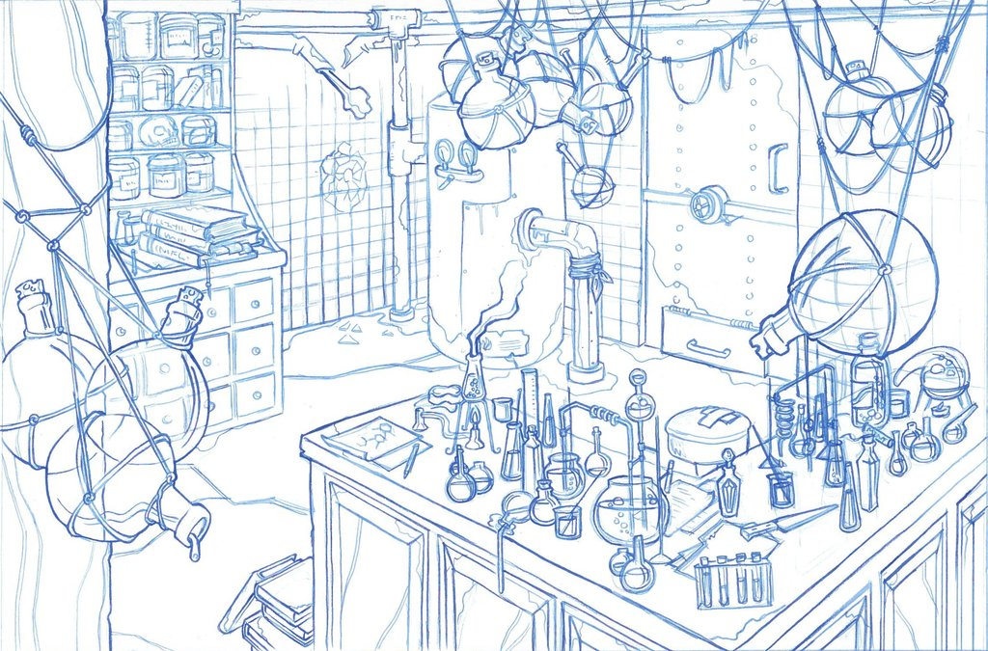

Tracker 1

Orderly views of your chaos 1

Introduction 3

Environment 3

Home Page Quick Entry Forms 4

Register ID 4

Find ID 4

Transfer 4

Registration 4

Tags 5

Project entry and verification 6

Initial Contents 6

Registering stacks 8

Racks 8

Scan of Rack Contents 8

Rack transfers 9

Component display and update 9

Rack verification 10

Transfers 13

Cherry Picking 14

Transferring Only Wells Containing Samples 15

Graphs 16

Contents 19

EZPASS Creation 20

Walk Up Sequencing File Creation 21

Robot Instructions 21

Search 23

A Very Brief Technical Overview 25

Example Workflow 26

Creation of Jira Data 26

Creation of BSP Rack 26

Scan of Rack Contents 28

Confirmation of Rack Contents 29

Creation of Manufacturer Antibody Tubes 31

Creation of Antibody Rack 32

Creation of Antibody Plate 35

Creation of Molecular Barcode Plate 38

Combining all the pieces 39

Creating sequencing tube and walkup sequencing form 42

# Introduction

Tracker is used to track lab components: plates, tube and racks. Components are tracked via two steps: registration and transfers. First individual components are registered into Tracker. Next, transfers are done between registered components.

Using the information input during registrations and transfers, Tracker provides verification and reports of component contents. In addition, lab protocols can be tracked and viewed later to see the steps and components that went into making a final product.

This document is a users guide to Tracker.

# Environment

Tracker runs as a web application, available from any web browser that can connect to Broad’s internal network. To access Tracker enter the url [http://btllims.broadinstitute.org:9000](http://btllims.broadinstitute.org:9000/) in the browser’s navigation bar.

Tracker’s home page has a number of “quick entry” forms at the bottom of the page to start the most common operations. In addition component searches and registration of plate stacks can be done. The home page is shown below:

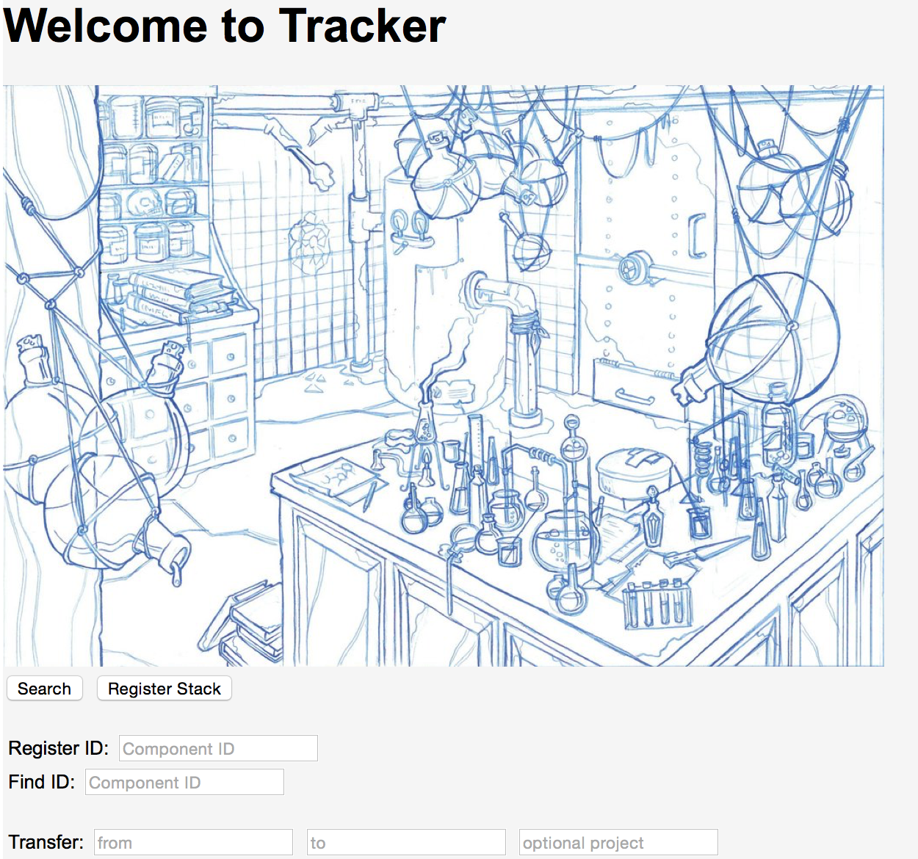

Home Page

Status messages are displayed at the top of the page in red when operations complete or additional information must be provided. For example:

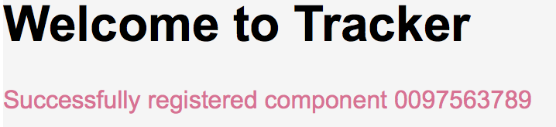

Message Display

The home page is returned to from any other page by simply clicking on the *Home* button located at the bottom left corner of the page.

## Home Page Quick Entry Forms

### Register ID

Before any operations are done with a component it must be registered with a unique ID supplied by the user. Normally this ID is the barcode attached to the component, which is easily input via a barcode scanner. To register a component set its ID in the *Component ID* field following the *Register ID:* label and hit return to be directed to forms used to complete the registration process. Additional information about the registration process is found in the section “Registration”.

### Find ID

Once a component is registered it can be edit, have its contents transferred to another component, or have verification or reports of its contents done. To go to the page that displays details about an individual component and contains the preceding operations, input the component’s ID in the *Component ID* field following the *Find ID:* label and hit return. Additional information about a components display page is found in the section “Component display and update”.

### Transfer

The *Transfer:* quick entry form is used to transfer contents between registered components. The source component ID is entered in the *from* field, the target ID in the *to* field and optionally an associated project is entered into the *optional project* field. Upon hitting the return key, if any additional information pertaining to the transfer such as a component quadrant is needed, a new page appears to query for the additional data. Additional information about transfers is found in the section “Transfers”.

# Registration

After entering an ID in the *Register ID* quick entry form a page appears to enter the component type. Based on the component type a final registration page appears to enter the type specific attributes for the component. Following are examples of the two pages:

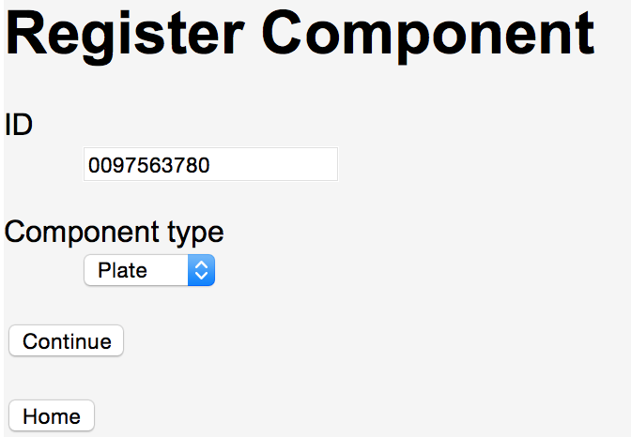

Register Component Type

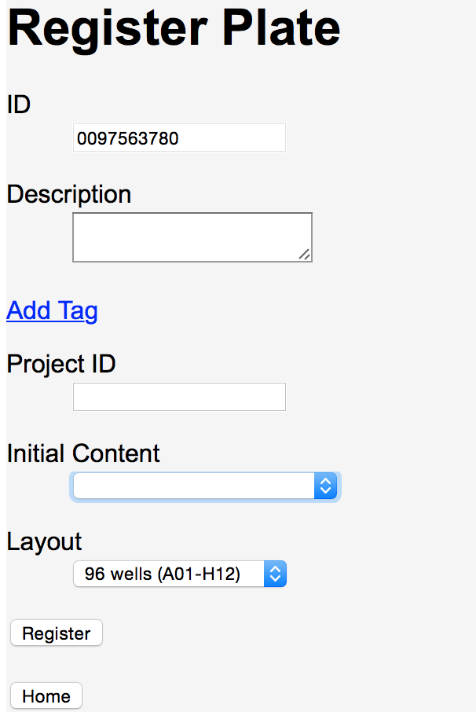

Plate Registration

*Description* can be set to any value. Searches can find any text contained within a description. For example, if one component has the description “The best component” and another “The worst component” searching for “component” will find both the preceding entries.

*Layout* must be specified for plates and racks. Two layouts are available: 96 and 384.

## Tags

Sometimes there is a need to add additional attributes to supplement the fields already in place for a component type. These attributes may simply be a tag name, such as “Destroyed”. Other attributes may have both a name and a value, for example “Reason for destruction”: “Dropped on floor”. To add an attribute to a component, choose the Add Tag option. That will display a place to put the tag name and an optional associated value. For example:

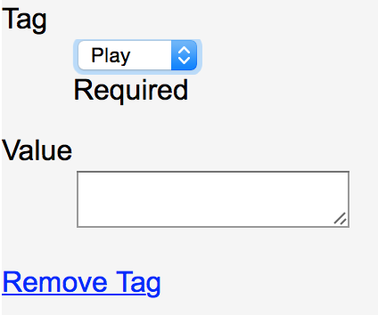

Add Tag form

The Tag field is a drop down list with all previous tag names used and a final choice of “other…”. To avoid duplicate tag names (e.g., grams, gm, weight (gm), …) it is best to choose one of the names already in the tag list. However, if none of the previously used names is appropriate then the “other…” choice is used to enter a new tag as shown below:

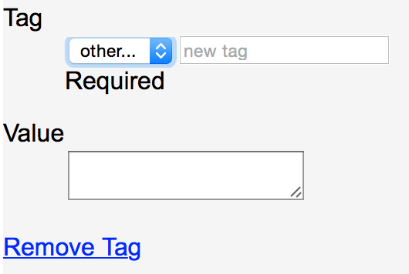

Add Tag other… form

Any number of tags can be added to a component. To remove a tag, select the *Remove Tag* option displayed below the tag name and value.

Tags can be used to search for components. See the “Search” section for more details.

## Project entry and verification

*Project ID* is used to verify that the component is part of a specified Jira issue. A *Project ID* set for a sample plate or rack must be the related Jira ticket ID (e.g., SSF-780) that the component is being used for.

Within Jira a rack is associated with a ticket when a BSP plate map is attached to the Jira ticket. When *Project ID* is set in Tracker for a BSP sample rack, if it is not the Jira ticket associated with the rack then the registration is aborted and an error message is displayed containing the actual Jira ticket ID, if any, the component is associated with.

Sample maps are attached to Jira tickets to register a plate’s contents. When a Tracker plate’s initial contents is set to *Sample Plate* the *Project ID* set for the plate must match the Jira ticket containing the plate’s sample map.

## Initial Contents

*Initial Content* is used to set the initial contents, if any, of the component. *Initial Content* is often used for components that will be the source of transfers. When a component with initial contents is transferred to another component the contents are usually transferred as well. The transfer of contents occurs across multiple transfers so a component’s contents are set from both direct and indirect transfers. Currently there are three types of initial contents that can be set: a sample type (Sample Plate) or MIDs (Molecular IDs or barcodes) for a plate, an antibody for a tube, and a tube type for a rack. Following is a display of the drop down lists used for *Initial Content*.

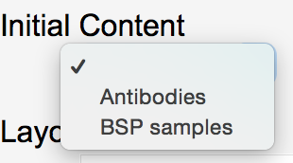

Rack Tube Type Selection

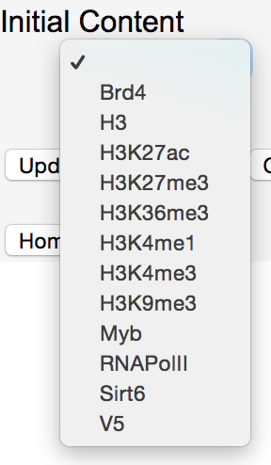

Tube Antibody Selection

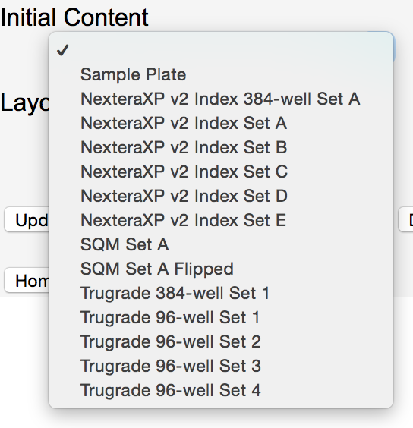

Plate Sample Plate or MID Selection

# Registering stacks

Registering stacks of components is similar to registering a single component except that a list of IDs, instead of a single ID, is registered. All the components in the stack must be the same type and the attributes for the components, except for ID, are entered once and applied to all the components in the stack. To register a stack of components press the *Register Stack* button to display the following page:

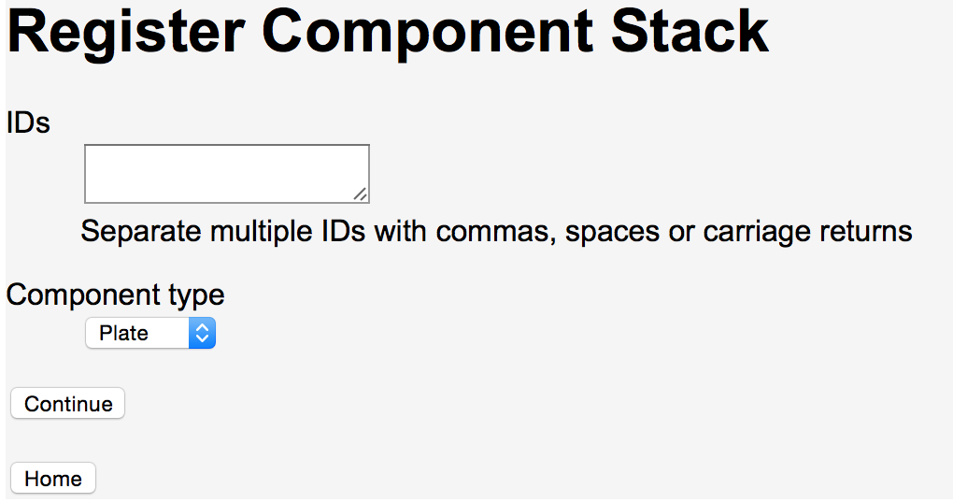

Register Stack IDs

As noted in the display, commas, spaces or carriage returns can separate IDs. If using a barcode scanner to scan in a stack be sure that the scanner inserts one of the required characters between IDs.

The final stack registration page is component type specific and identical to the pages used for registering a single ID entered in the home page’s *Register ID* quick entry form.

# Racks

In the following discussion all references to racks are to non-BSP racks, except as noted.

Racks are a special component because they are just holders of tubes. A rack does have any content other than the tubes themselves. Individual tubes can have content, so to track the contents of a rack’s tubes an operation done on a rack becomes a set of operations done on individual tubes.

## Scan of Rack Contents

To operate on a rack, Tracker must first be told what tubes are in the rack and where they are located. This information is input via a scan, done using a rack scanner that can read the 2D barcodes at the bottom of the tubes and create a “csv” file. An example of scan results follows (DATETIME column is optional):

|  |  |  |  |
| --- | --- | --- | --- |
| DATETIME | RACK | TUBE | BARCODE |
| 12/22/14 14:21 | CO-11227502 | A01 | 177159455 |
| 12/22/14 14:21 | CO-11227502 | B01 | 177159432 |
| 12/22/14 14:21 | CO-11227502 | C01 | 177159431 |
| 12/22/14 14:21 | CO-11227502 | D01 | 177159408 |
| … | … | … | … |

The scan results are entered into Tracker via the *Scan File* option on a rack’s display page. To enter a scan select the *Choose File* button below *Scan File*. A dialog box will pop up to select the “csv” file created by the rack scanner. Once the file is selected the rack’s display page will show the name of the file. Select the *Update* button to associate the rack with the chosen file.

When a scan file is entered for a rack, any tubes not previously registered are automatically registered. Tubes automatically registered contain the description “Tube registered from scan of rack *rackID*” where rackID is the ID for the rack associated with the scan.

If tubes are removed or inserted into a rack or the location of tubes in a rack ever change a new scan of the rack must be entered.

## Rack transfers

A transfer into or out of a rack becomes multiple transfers into or out of the rack’s tubes. For example, a transfer from a 96-well plate to a 96-tube rack becomes 96 transfers of a single well from the plate to a tube. Each transfer is between a well and tube at the same location: well A01 to the tube at A01, A02 to A02, etc. Tracker does not associate the transfer with the rack. After the transfer is complete the individual tubes can be used, independent of the rack.

Rack-to-rack transfers are a convenient way to do mother to daughter tube transfers. If mother tubes are set in one rack and daughter tubes in another then a transfer from the rack of mother tubes to the daughter tubes’ rack will automatically register the daughter tubes and set their contents to the mother tube’s content at corresponding locations.

# Component display and update

When a component is selected, either via the *Find ID* quick entry form or from *Search* results, details about the component are displayed. Following is the display for tube 0098973031:

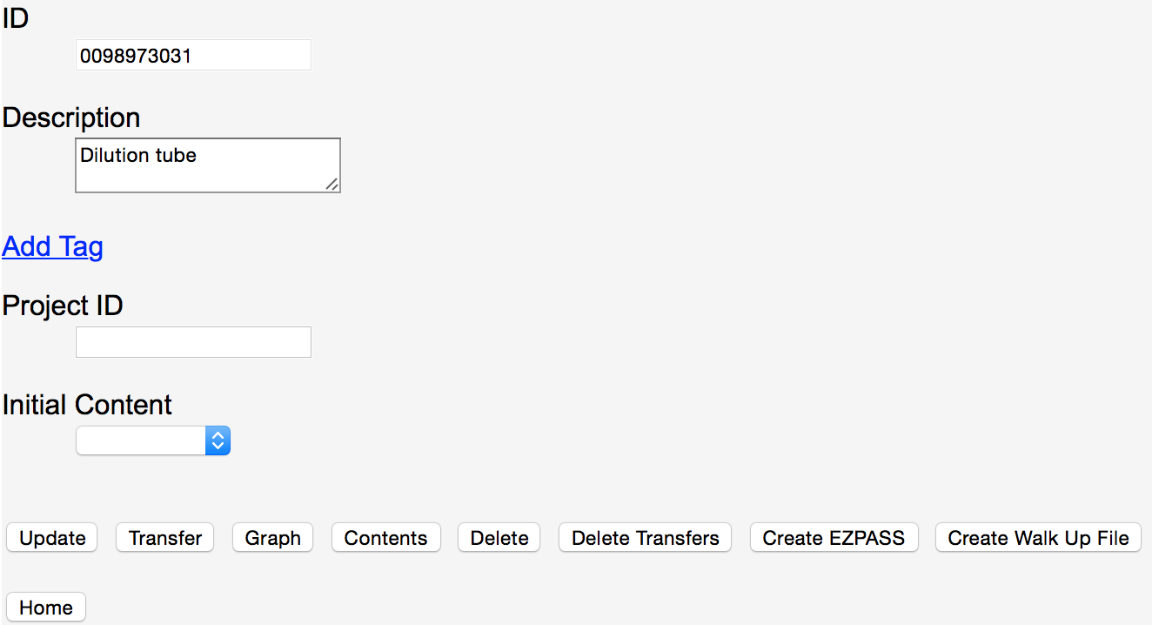

Component Display

In addition to the component details displayed, there are a number of operations that are done from this page:

* Fields are modified and then updated using the *Update* button.
* Transfers, with the displayed component as the source, are recorded using the *Transfer* button.
* A graph of all transfers, direct or indirect, to and from the component is displayed using the *Graph* button.
* Contents of the component are displayed using the *Contents* button. Contents include all initial contents set or transferred into the component as well as sample names. Rack contents show the contents of the rack’s tubes as well as links to display the individual tubes.
* The component and all its associated direct transfers are deleted via the *Delete* button.
* Transfers from the component to another component specified in a follow up page are deleted using the *Delete Transfers* button. This operation is only used to delete direct transfers and does not delete the component itself.
* An EZPASS is created using the *Create EZPASS* button. The EZPASS includes information deduced from transfers, such as molecular barcodes and sample information. EZPASS creation is only available for tubes.
* A walk up sequencing sheet is created using the *Create Walk Up File* button. The walk up sequencing sheet includes molecular barcodes and sample names. Walk up sequencing sheet creation is only available for tubes.
* Verification of a component’s sample content is done via the *BSP Report* button. BSP reports are only available for BSP samples racks.

## Rack verification

Following is the display for a rack:

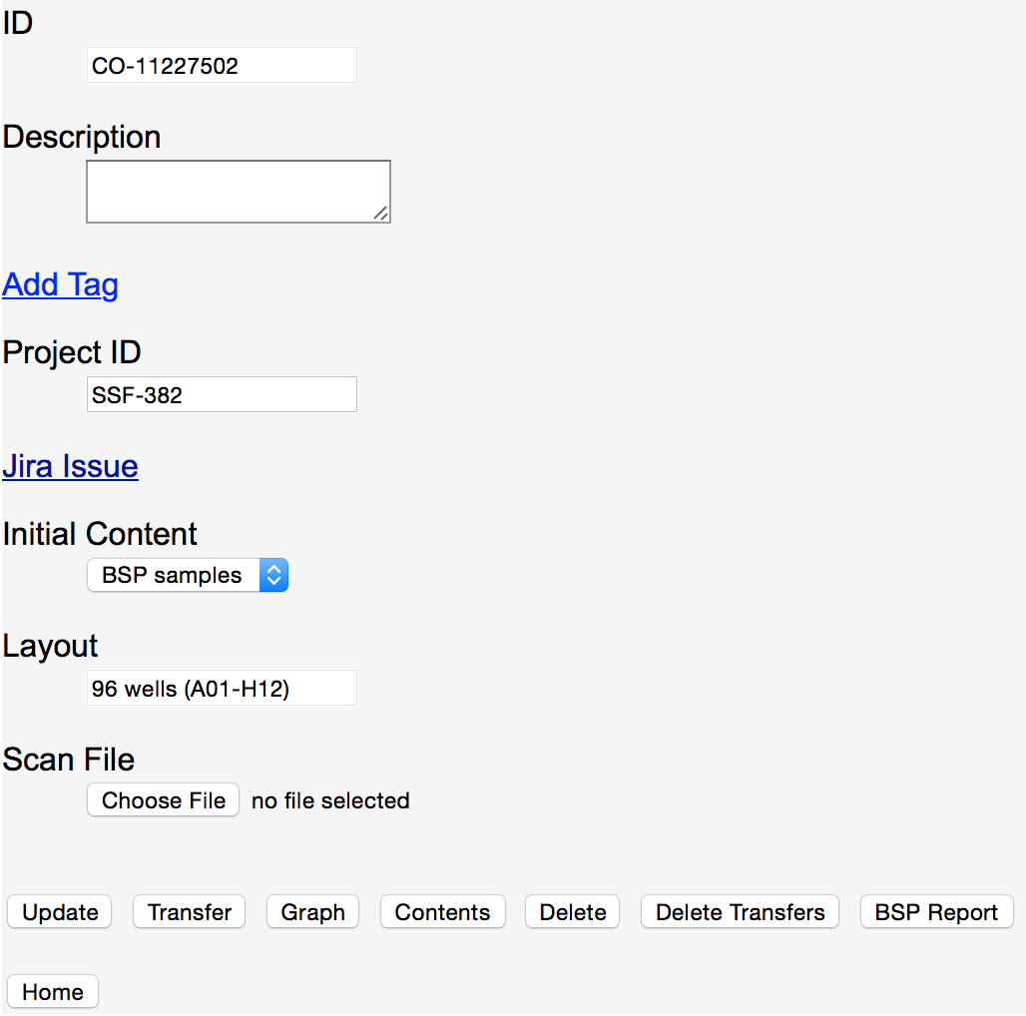

Rack Display Page

Reports for actual vs. expected content can be done for BSP sample racks. Expected contents are determined by data entered in the Jira ticket associated with the component. Note that the Jira ticket is displayed by selecting the *Jira Issue* option that appears once a *Project ID* has been set for the component.

Before verifying the contents of a rack the following must occur:

* In the associated Jira ticket the BSP plate map must be attached.
* A scan of the 2D barcodes of the tubes in the rack must be done and associated with the component using the *Scan File* option in the rack display page.

After the BSP and rack scan associations have been set, selecting the *BSP Report* button verifies the contents of the rack. Following is an example of verification results:

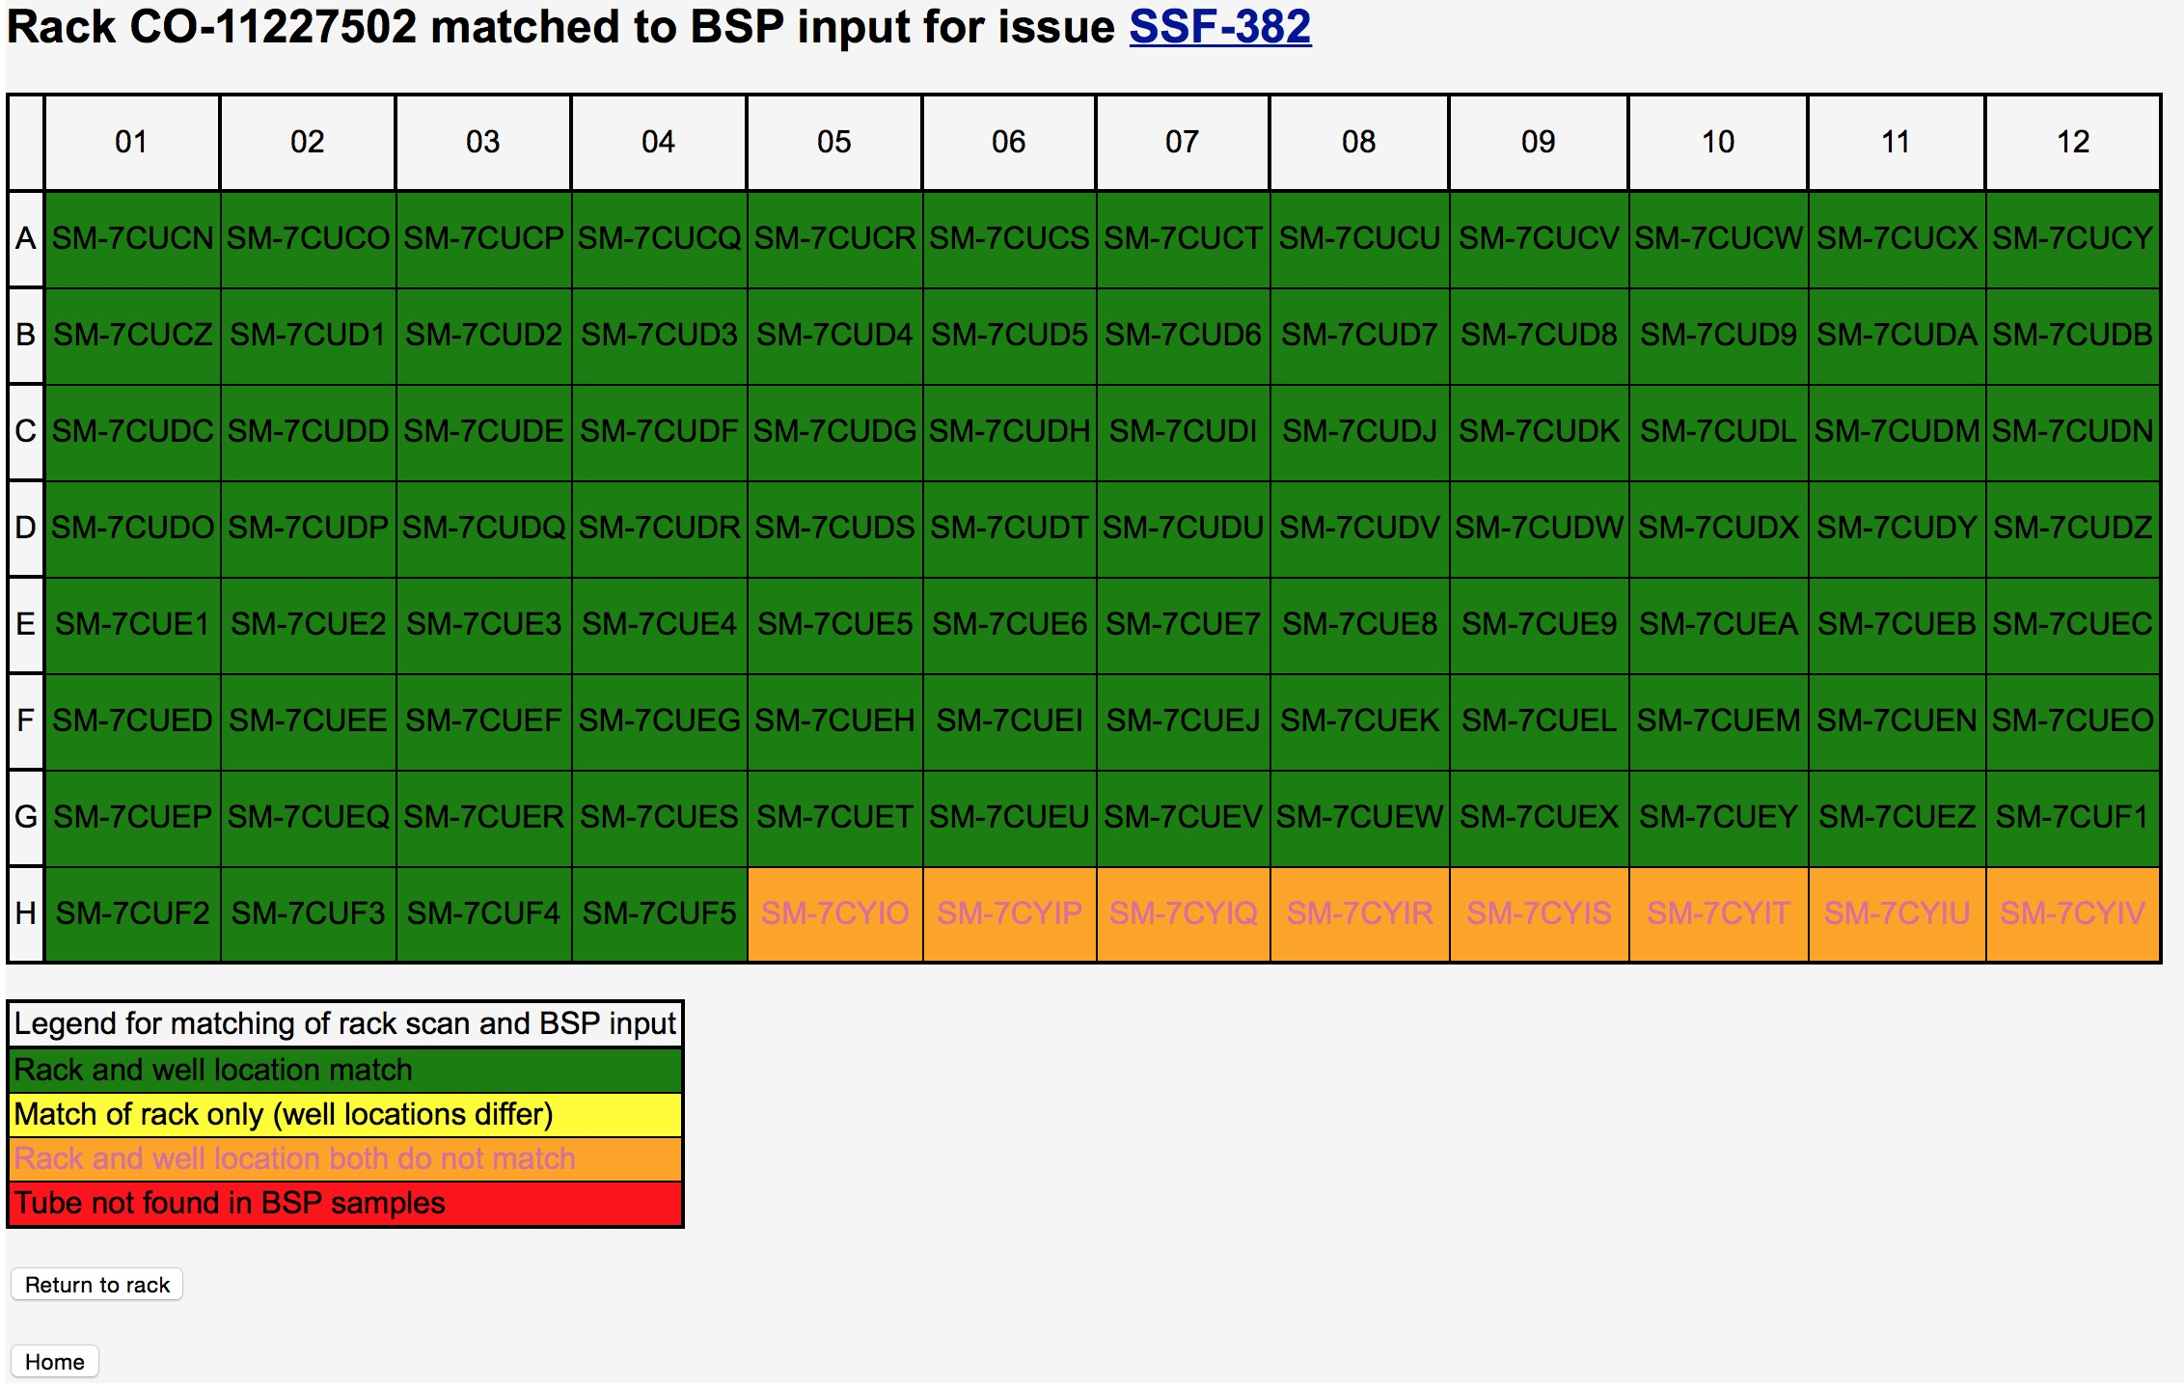

BSP Report

The page shows how the rack scan results compare with the reported contents from the BSP plate map. The match between the rack scan and the sample sheet is done using the tubes’ barcodes.

As the legend in the lower left of the screen indicates green locations are an exact match. For mismatches, the severity of the mismatch is indicated by colors (yellow to red) explained in the legend. The label (e.g., SM-7CUCN) in a box is the BSP sample ID for the tube found in that location in the rack. The locations used are from the scan entered for the rack scan. For example the tube in location H05, sample SM-7CYIO, was found at location H05 in the rack scan but found in a different rack in Jira’s BSP data.

If the BSP plate map includes information about antibodies the matching criteria is slightly different and based on whether the antibody associated with a location of a sample in the scanned tubes is the same as the antibody originally associated with that location in the BSP plate map. The legend for racks with antibody associations is:

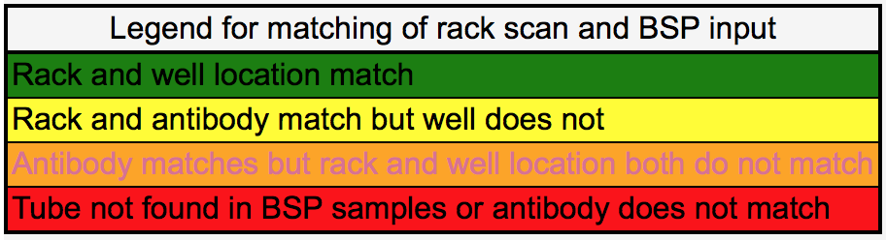

BSP Report Legend for Antibody Matching

# Transfers

Transfers are used to track when the contents of one component are moved to another component. Components must be registered before they can be part of a transfer. The source and destination of transfers are identified by component IDs. Valid transfers are:

- Rack to Rack, Plate or Tube

- Plate to Plate, Rack or Tube

- Tube to Tube, Rack or Plate

BSP racks are an exception. Because their contents are set before being registered they can never be the destination of a transfer.

Following is example of the transfer page initiated for a tube 000008411869:

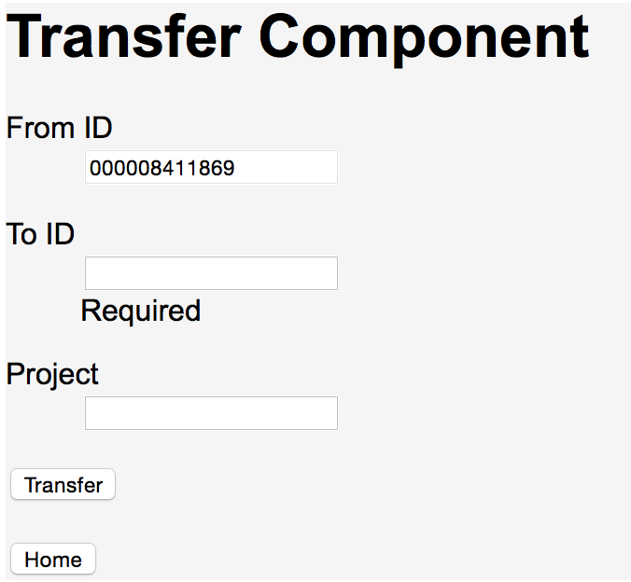

Initial Transfer Page

In addition to the *from ID* and *to ID* an optional *Project* can be specified. If project is specified a check is done that the project is set for either a component transferred into the source, directly or indirectly, or the transfer source itself. If the specified project is not found then an error is reported and the transfer is aborted.

Transfers of plates and racks need not be for the entire component. In the following discussion “wells” is used to refer to either a plate’s wells or a rack’s tubes. When transferring between different size components, for example a 96-well and 384-well plate, a quadrant must be specified. In addition, for all transfers involving racks or plates, the transfer can be limited to 24 or 48-well slices or cherry picked wells.

Following is the Transfer page, from a 96-well plate to a 384-well plate, requesting quadrant and optional slice information. Slice choices are displayed in the drop down list as rows and columns with *Cherry Pick Wells* as a final choice.

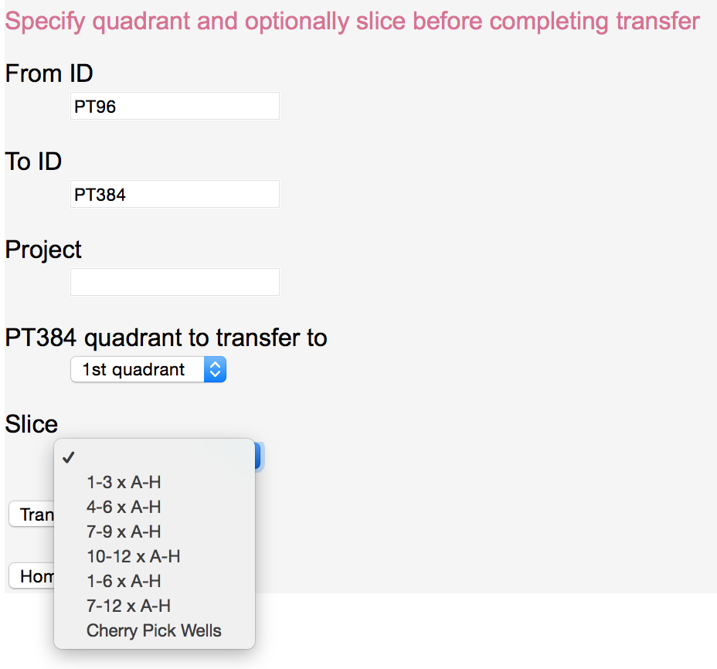

Transfer Page to Specify Transfer Quadrant and Slice

When both a quadrant and slice are selected the slice is taken from 96-well coordinates. For example, in the page above, if slice *10-12 x A-H* is chosen from the *1st quadrant* then the 24 wells covered by the slice 10-12 x A-H in the 96-well source plate are transferred. Similarly, if the transfer was from a 384-well plate to a 96-well plate or between 384-well components, the wells transferred into are 10-12 x A-H in the 96-well target plate or a virtual 96-well component between the 384-well components.

## Cherry Picking

To pick individual wells the last slice choice, *Cherry Pick Wells*, must be selected. When a request to cherry pick wells is submitted an additional page appears to do the selection, as shown below:

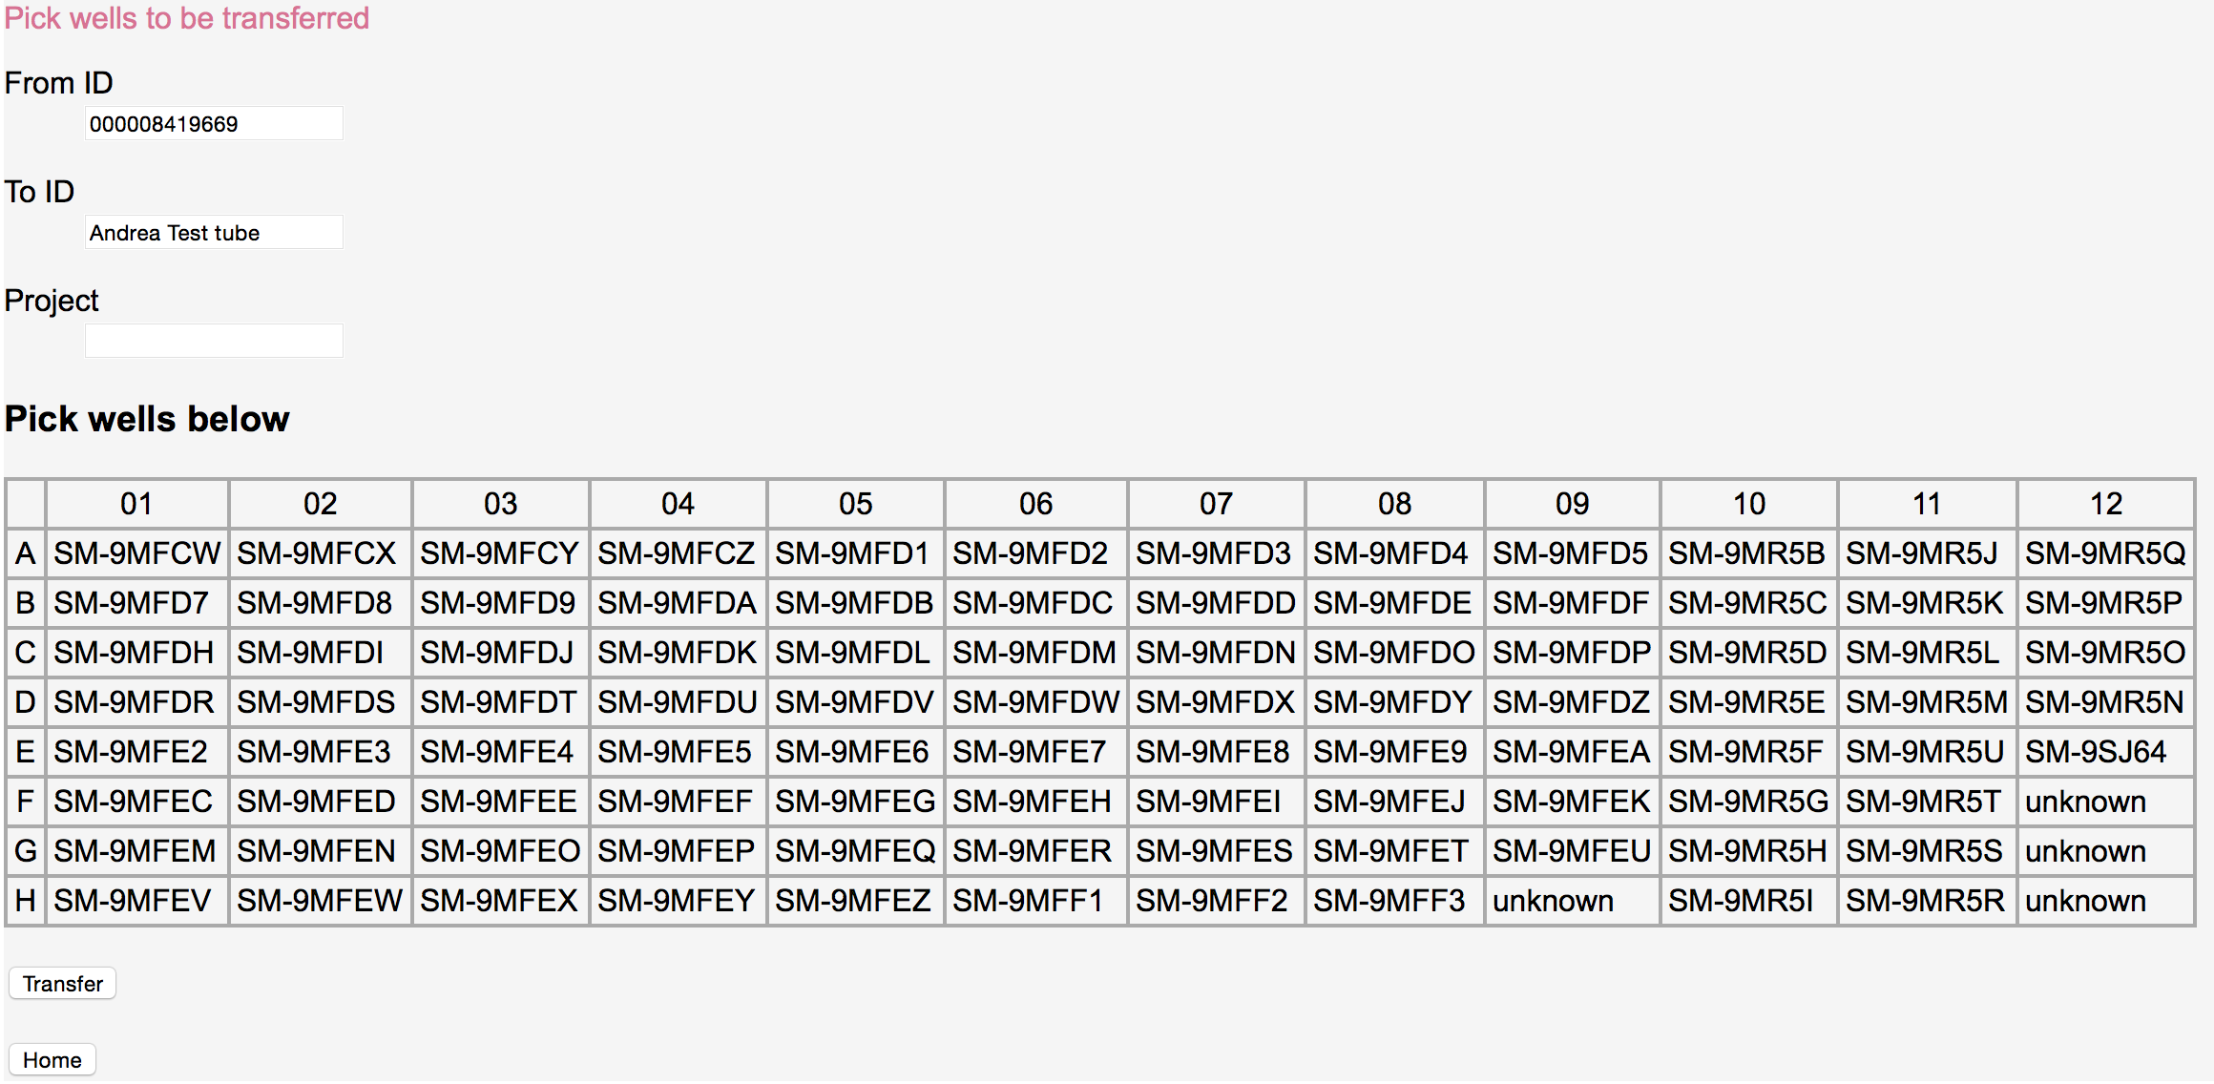

Transfer Page to Cherry Pick Wells

When a sample ID is known for a well’s contents it is displayed, otherwise “unknown” is set in the well’s location. To select wells the following UI choices are available:

* Mouse click to select an individual well and unselect any other wells previously selected.
* Mouse click while holding down the control key to select or unselect an individual well while leaving the selection state of other wells unchanged.
* Mouse click while holding down the shift key to select the range of wells between the last selected well and the one now being selected and unselect any other wells previously selected.
* Mouse click while holding down both the shift and control key to select a range of wells while leaving the selection state of other wells unchanged.

## Transferring Only Wells Containing Samples

If transferring a plate to a tube, it is often desirable to only transfer the wells containing samples. For example, if a plate contains some wells with both samples and attached molecular barcodes but other wells contain only barcodes, it is likely that only the wells containing samples are being transferred to the tube. If the entire plate is transferred all the unattached barcodes become attached to all the samples. To prevent this from occurring, and only transfer wells from the source plate that contains samples, check the “Only transfer wells with samples?” box.

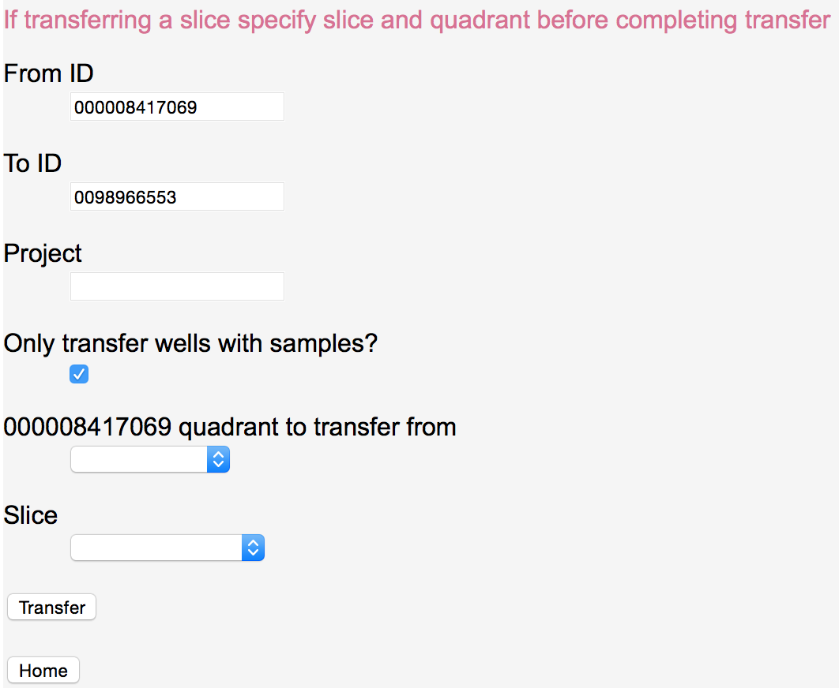

Transfer Page Specifying to Only Transfer Wells With Samples

## Graphs

Tracker keeps track of transfers using directed graph. Components are the nodes of the graphs and transfers are the edges. Using these graphs a number of operations can be done. The most basic operation is to display the graph. When a display is requested, using the *Graph* button, a pop-up window displays the graph for the component. Other components transferred into or out of the component, directly via a single transfer or indirectly via multiple transfers, are shown in the display. Between the components are arrowed lines showing the directions of the transfer. Within each component’s rectangle is the component’s ID, description (up to 23 characters), project and initial contents. Following is a graph for the collection plate 000008415069. The project (SSF-766) associated with the BSP samples input rack SSF766 is displayed along with descriptions for other components and the initial contents (NexteraXP v2 Index Set C) of 000008402269. Racks are displayed as 3-d rectangles, plates as plain rectangles and tubes as rectangles with rounded corners.

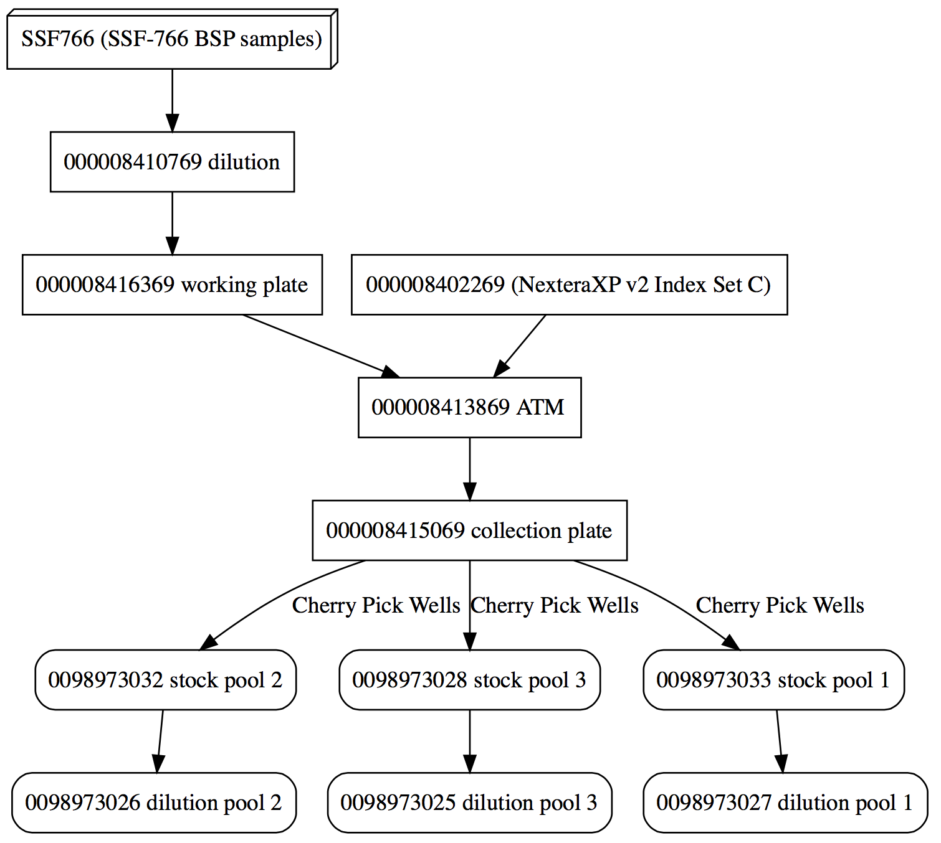

Component Graph

Clicking on a component’s label navigates to the component’s display. Clicking a label on the line representing a transfer usually displays a map of the source wells, with a destination well location set for each source well being transferred. Following is the display when the “Cherry Pick Wells” label for the line between 000008415069 and 0098973032 is selected:

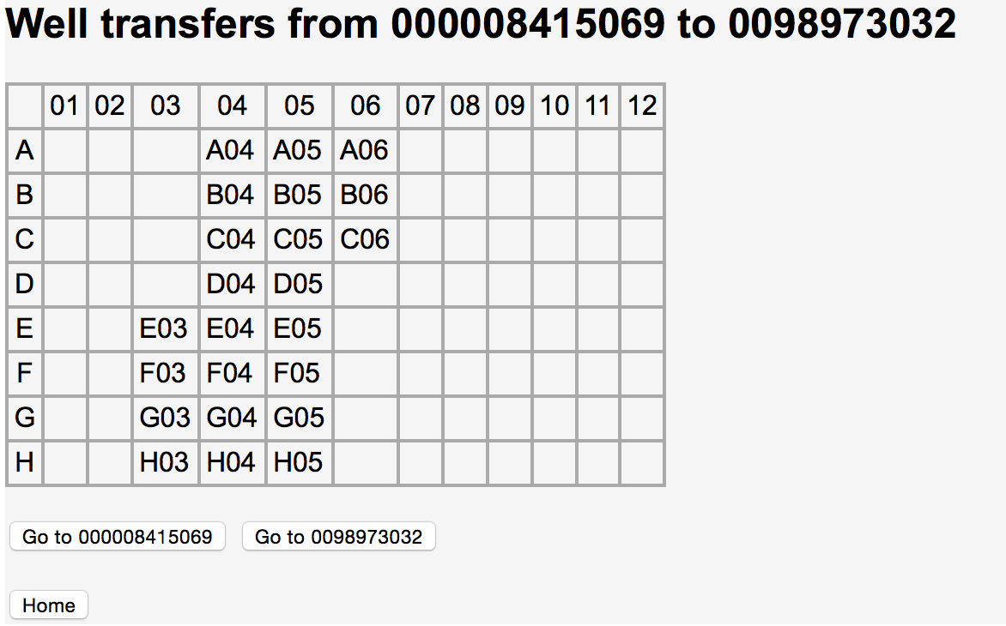

Well Transfers

Unlike the previous example, when transfers take place between different size components the source and destination wells may not be the same. Also, if the transfer is from a tube to a plate or rack, the destination component is shown with the wells marked to indicate where the tube’s content is transferred. For example, if antibody tubes are transferred into wells of the plate ABXX, as show below:

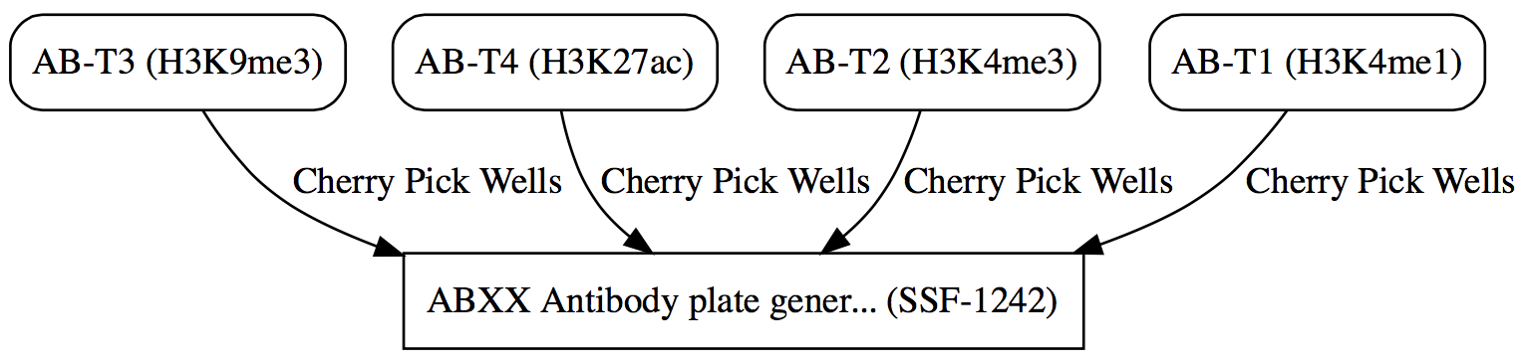

Tube to Plate Graph

the transfers from a tube to the plate are displayed as shown in the following example, with each destination well in the plate marked by *XX*:

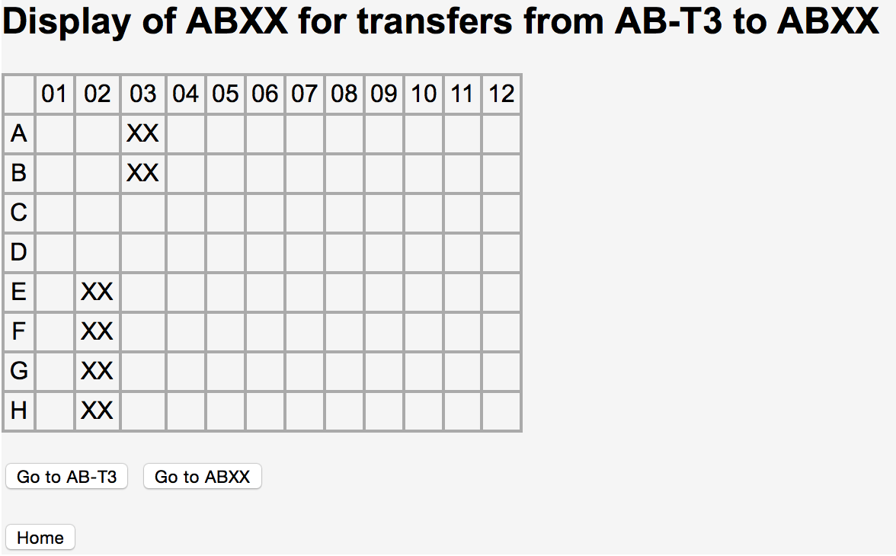

Tube to Plate Transfer

Finally, when there is no label on a graph’s transfer line that implies that the source and destination are the same size and that the entire source was transferred.

# Contents

Contents of a component are determined by the component’s own initial contents along with initial contents of any other components transferred, directly or indirectly, into the component. The graph containing these transfers is displayed using the *Graph* button in a component’s display.

The final contents of a component are calculated based on the contents of all the components leading into the target component. In particular, MIDs (molecular IDs or barcodes) and antibodies are attached to samples based on well locations of the MIDs, antibodies and samples. For example, in the preceding *Component Graph* for tube 0098973031, the sample contents originating in the rack CO-14655311 are combined with the “NexteraXP v2 Index Set A” MIDs to create MID tagged samples in the ATM plate and beyond.

Rules for combining contents are:

* Molecular barcodes and antibodies are attached to the first sample they encounter. Once attached to a sample the barcodes and antibodies cannot be attached to any additional samples, however multiple barcodes and antibodies can be attached to a single sample.
* If multiple samples are transferred into a location where there is an unattached molecular barcode or antibody the sample chosen to attach to the molecular barcode or antibody is whichever one is transferred first.

To see contents for a component click the *Contents* button in a component’s display page. Following is the display for a 96-well plate that contains samples and molecular barcodes.

## 

Contents Display

A component’s contents can also be output in file formats suitable for input for sequencing and analysis software.

## EZPASS Creation

When an EZPASS is requested for a tube a new page appears to request additional attributes needed to complete the EZPASS. Following is an example of the “Create EZPASS” page:

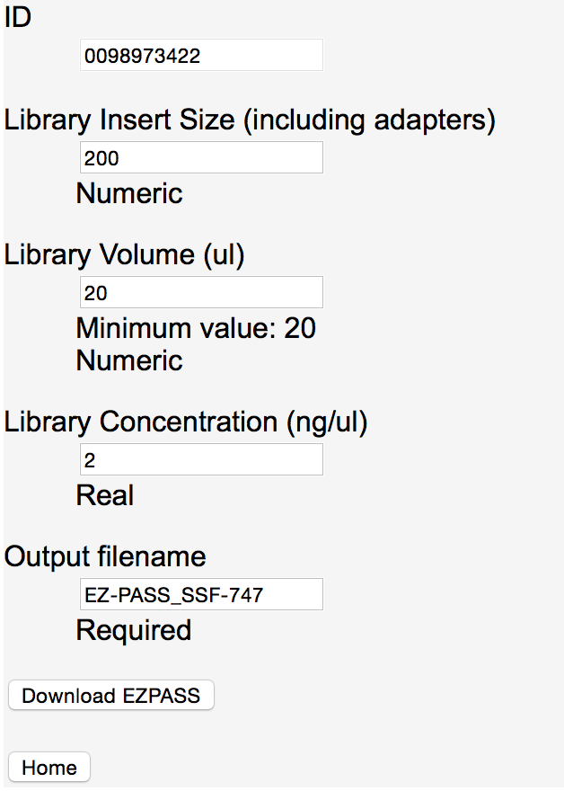

Create EZPASS

After all the requested attributes are filled in, the *Download EZPASS* button is selected to generate the EZPASS. Generation of the EZPASS requires finding the contents of the selected tube and then creating the EZPASS spreadsheet based on the contents found.

After the EZPASS is generated it is downloaded as a file named by default either *EZ-PASS_ projectName.xlsx* or *EZ-PASS_componentID*.*xlsx*, for example EZ-PASS_SSF-747.xlsx. If a project is found for the target component or any of the components transferred into the target then that project name is used. Otherwise the filename uses the target component id. The filename is overridden by specifying an *Output filename*.

## Walk Up Sequencing File Creation

As an alternative to an EZPASS, a walk up sequencing file is created for a tube by selecting the *Create Walk Up File* button. The walk up file generated has the name *projectName_tubeID.csv* or *tubeID.csv* if the tube does not have a project ID. Similar to an EZPASS, a walk up sequencing sheet is created by looking at the contents, in particular MIDs and samples, which have been transferred into a tube. A walk up sequencing sheet is a “csv” (comma separated value) file with three columns: SampleName, IndexBarcode1 and IndexBarcode2. SampleName is based on the collaborator sample name; IndexBarcode1 contains the P5 barcode sequence; IndexBarcode2 the P7 barcode sequence. The SampleName is created by first replacing any non-alphanumeric characters in the collaborator sample name, except underscore (“_”) and dash (“-”), with an underscore. Following the collaborator sample name, if an antibody is matched with the sample, an underscore, followed by the antibody name, is appended to the sample name. Finally to complete the sample name, and guarantee uniqueness, an underscore followed by the sample’s original position in the input sample rack is placed at the end of the name. Following is an example of the start of a walk up sequencing sheet for samples not containing antibodies.

SampleName,IndexBarcode1,IndexBarcode2

MSM79H52_H09,TCTCTCCG,CCTAAGAC

HSM7J4JT_G12,CGTCTAAT,TCGACGTC

CSM67U9R_E10,AAGGAGTA,CGATCAGT

CSM79HG7_D05,ACTGCATA,TACGCTGC

PSM6XBVY_B04,TATCCTCT,CGGAGCCT

HSM67VDR_F07,CTAAGCCT,TAGCGCTC

CSM79HPQ_A08,CTCTCTAT,ACTGAGCG

CSM79HJE_E08,AAGGAGTA,ACTGAGCG

Walk Up Sequencing Sheet

## Robot Instructions

Instructions, to create a plate of antibodies, are created and downloaded by selecting the *Create Antibody Plate* button in a rack display with *Initial Content* set to *Antibodies*. Instructions are generated to transfer antibodies from the tubes in the source rack to the proper locations in the destination plate. When *Create Antibody Plate* is clicked in a rack’s display, the following page is shown:

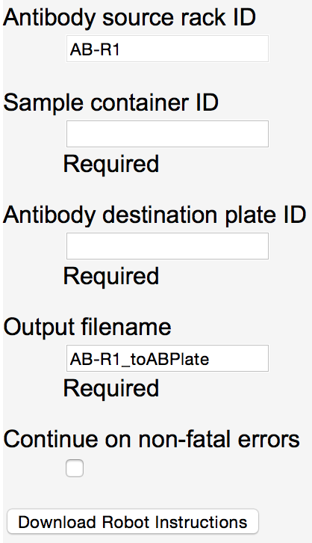

Creating Robot Instructions

*Antibody source rack ID* is the ID of the displayed rack where *Create Antibody Plate* was selected. This rack must contain one tube for each antibody in the set of antibodies associated with the BSP samples. For example, if there are 24 samples and 8 are associated with antibody H3K9me3, 8 with H3K4me3 and 8 with H3K27ac then there must be one tube in the antibody source rack containing antibody H3K9me3, one containing H3K4me3 and one containing H3K27ac.

*Sample container ID* is set to the ID for the container that contains the BSP samples. This is often the BSP rack, but can be any container that has had samples transferred to it, directly or indirectly, from a BSP rack. Each BSP sample must have a related antibody in the BSP plate map associated with the project.

*Antibody destination plate ID* is set to the ID of the destination plate being created to contain antibodies for the samples. Well locations of antibodies in the plate are set to properly match the sample placement in the sample container. For example if the sample in location A01 in the sample container is associated with antibody H3K4me3 then the generated robot instructions contain a directive to do a transfer from a tube containing H3K4me3 to the location A01 on the destination plate.

The destination plate need not be registered before the robot instructions are generated. If the plate is not registered it will automatically be registered with a description “Antibody plate generated for sample <componentType> <ID>” where <componentType> is the type of the destination plate (e.g., rack or plate) and <ID> is the *Antibody destination plate ID*. The destination plate’s project is set to be the same as the sample container’s.

*Output filename* is the name given to the file generated with the robot instructions. By default this name is set to the source rack ID followed by “_toABPlate”. The file generated is a csv (comma separated values) file given the extension “.csv”. An example of a generated file follows:

AB Name,Volume,Source AB Well Location,Destination Working Plate Well Location

H3K9me3,1,A3,A11

H3K9me3,1,A3,A10

H3K27me3,1,A4,B1

RNAPolII,1,A1,A4

H3,1,A6,B12

H3K4me3,1,A5,B5

Brd4,5,A2,A5

H3,1,A6,B9

H3K9me3,1,A3,A12

H3K27me3,1,A4,B2

H3K4me3,1,A5,B6

RNAPolII,1,A1,A1

Brd4,5,A2,A8

Brd4,5,A2,A6

RNAPolII,1,A1,A2

H3K27me3,1,A4,B3

H3,1,A6,B10

H3K4me3,1,A5,B8

H3K27me3,1,A4,B4

Brd4,5,A2,A7

H3K4me3,1,A5,B7

H3K9me3,1,A3,A9

RNAPolII,1,A1,A3

H3,1,A6,B11

Generated Robot Instructions to Create an Antibody Plate

*Continue on non-fatal errors* is chosen if errors, such as there not being an antibody associated with a sample in the BSP sample sheet, are to be treated as non-fatal. By default this option is not chosen and any errors found will be treated as fatal and abort the creation of the robot instructions.

In addition to creating the instruction file, *Download Robot Instructions* automatically generates a number of transfers. Specifically, for each antibody tube used, a transfer from the tube to the plate wells receiving the antibody is created.

# Search

Searching for one or more components based on multiple criteria is done using the search page displayed when the *Search* button on the home page is selected. A blank search page looks as follows:

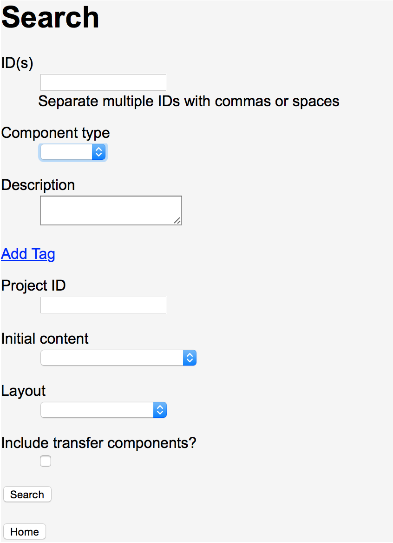

Search

Each criteria specified, with the exception of *Include transfer components?*, narrows the selection criteria. If no criterion is specified all registered components are found. Otherwise the search results are limited to match all the criteria specified. Attribute matching rules are:

* *ID(s)*, *Component type*, *Project ID*, *Initial content* and *Layout* must be exact matches.
* *Description* matches if the specified text is contained anywhere within a component’s description. Description matching is case insensitive.
* Tags, added via the *Add Tag* selection, must specify a *Tag* name to match. If a *Value* is specified with the name, matching components must have at least one tag with the specified *Tag* name and a value containing the specified *Value*. *Value* matching is case insensitive. If a *Value* is not specified then all components with the specified *Tag* name are considered a match, regardless of the tags’ associated values.

When *Include transfer components?* is checked, in addition to the components found based on the other search criteria, any components that are part of transfers involving the components found are also included in the search results. Direct and indirect transfers are included, similar to the results of a component’s graph display.

Results of a search are displayed in a table as follows:

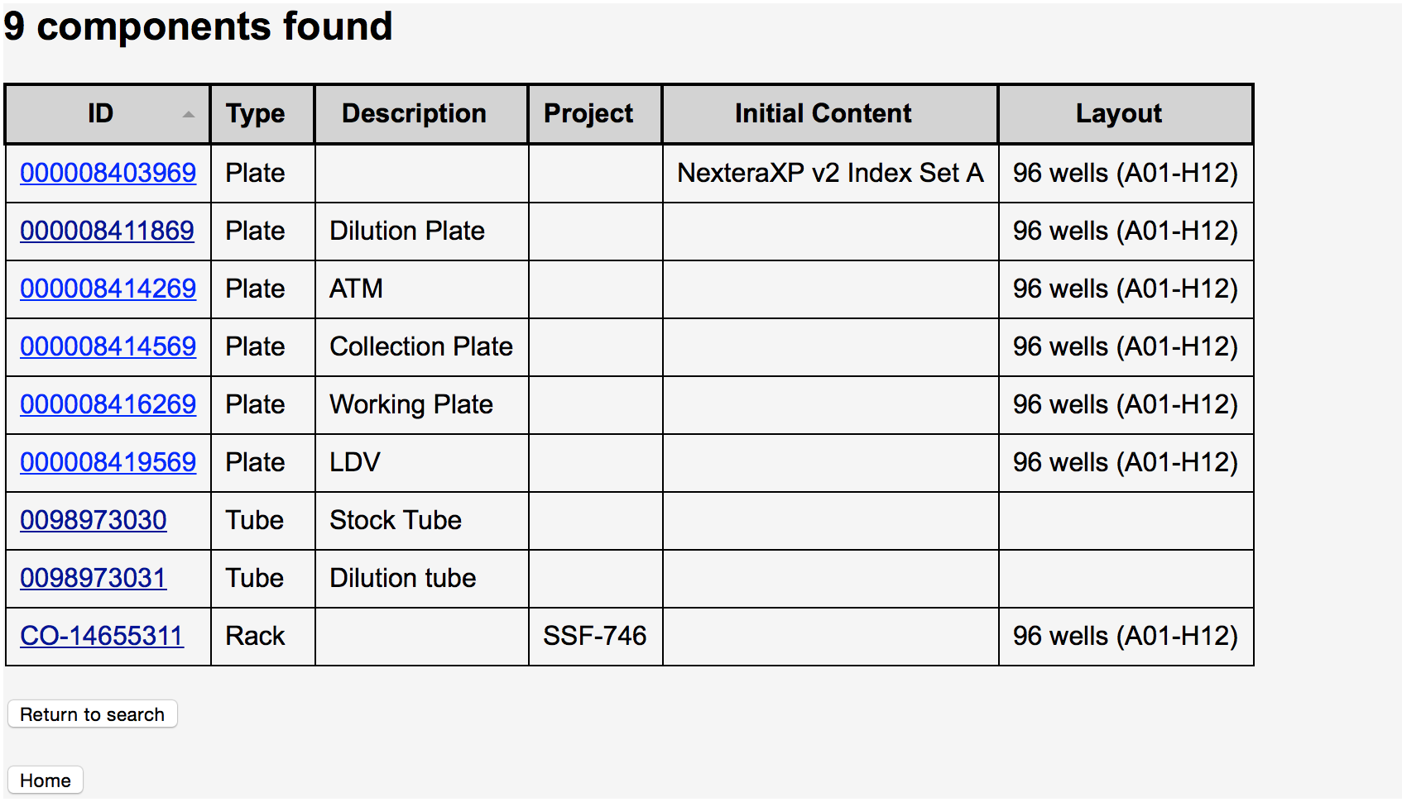

Results of Search for ID 0098973031 with Include of Transfer Components

The resultant table is initially sorted by ID but can be sorted by another field by selecting the wanted table heading. To go to any of the found components’ display page simply click on the component ID.

# A Very Brief Technical Overview

At a high level Tracker is very simple. It consists of components, initial contents and a DAG (directed acyclical graph). Components have a universal id (e.g., a barcode) and a type (e.g., plate, tube or rack). Optionally a component can have initial contents (e.g., an antibody, a molecular barcode set or a sample set).

When one component is transferred to another the transfer is recorded in the DAG, which contains nodes that are components and edges that have source and destination component IDs. Having a source and destination makes the graph directed. The graph is maintained to be acyclical to insure a component is never transferred to itself, directly or indirectly.

To find the contents of a component, for example when making an EZPASS, walk-up sequencing pass or simply displaying the contents, the DAG is traversed. Specifically, the predecessors of the component are recursively examined to find all the initial contents that have been transferred, directly or indirectly, into the target component. The collection of all the initial contents becomes the contents of the target component.

# Example Workflow

Following is a simplified workflow to create a ChIP-Seq sequencing tube.

## Creation of Jira Data

The first step in this example is entering the BSP sample information. This is not done in Tracker. Instead the information is entered by a product manager as a platemap attachment to a Jira labset issue associated with the BSP samples. The platemap is an excel spreadsheet, with one row per sample, created via a query to the BSP database. It must include the following column headings, with values set for each sample except where designated as optional:

| Column Title | Description |
| --- | --- |
| Container | rack barcode |
| Manufacturer Tube Barcode | sample tube barcode |
| Position | sample tube position in rack |
| Sample ID | BSP sample ID |
| Stock Sample | BSP stock sample ID (optional) |
| Collaborator Participant ID | collaborator’s ID for sample source (optional) |
| Collaborator Sample ID | collaborator’s sample ID (optional) |
| GSSR Barcode | GSSR ID (optional) |
| Antibody | antibody to be associated with sample (optional) |

Users of Tracker just need to know the Jira ticket number, referred to as the Project ID within Tracker, to start working with a BSP sample rack.

Note, if the samples arrive in a plate instead of a rack then a samplemap spreadsheet must be attached to the Jira ticket with the following column headings:

| Column Title | Description |
| --- | --- |
| Position | well location of sample |
| Sample Identifier | collaborator’s sample ID |
| Organism | sample organism |
| Volume | sample volume (optional) |
| Conc or cell count | sample concentration or cell count (optional) |
| Buffer | sample buffer (e.g., TCL) (optional) |
| Cell or Tissue Type | sample cell or tissue type (e.g., CD3) (optional) |
| Reference Sequence | sample reference sequence (optional) |

## Creation of BSP Rack

The first step to use the BSP rack in Tracker is registration. To register the rack, put the cursor in the *Register ID* field on Tracker’s home page and input the rack’s barcode. Wherever a barcode is entered in Tracker any method of input works but it is assumed that a barcode scanner is used. Most barcode scanners will automatically add a return character (e.g., a carriage return) after the barcode. If the barcode scanner does not append a return character the return key must be typed to have Tracker proceed.

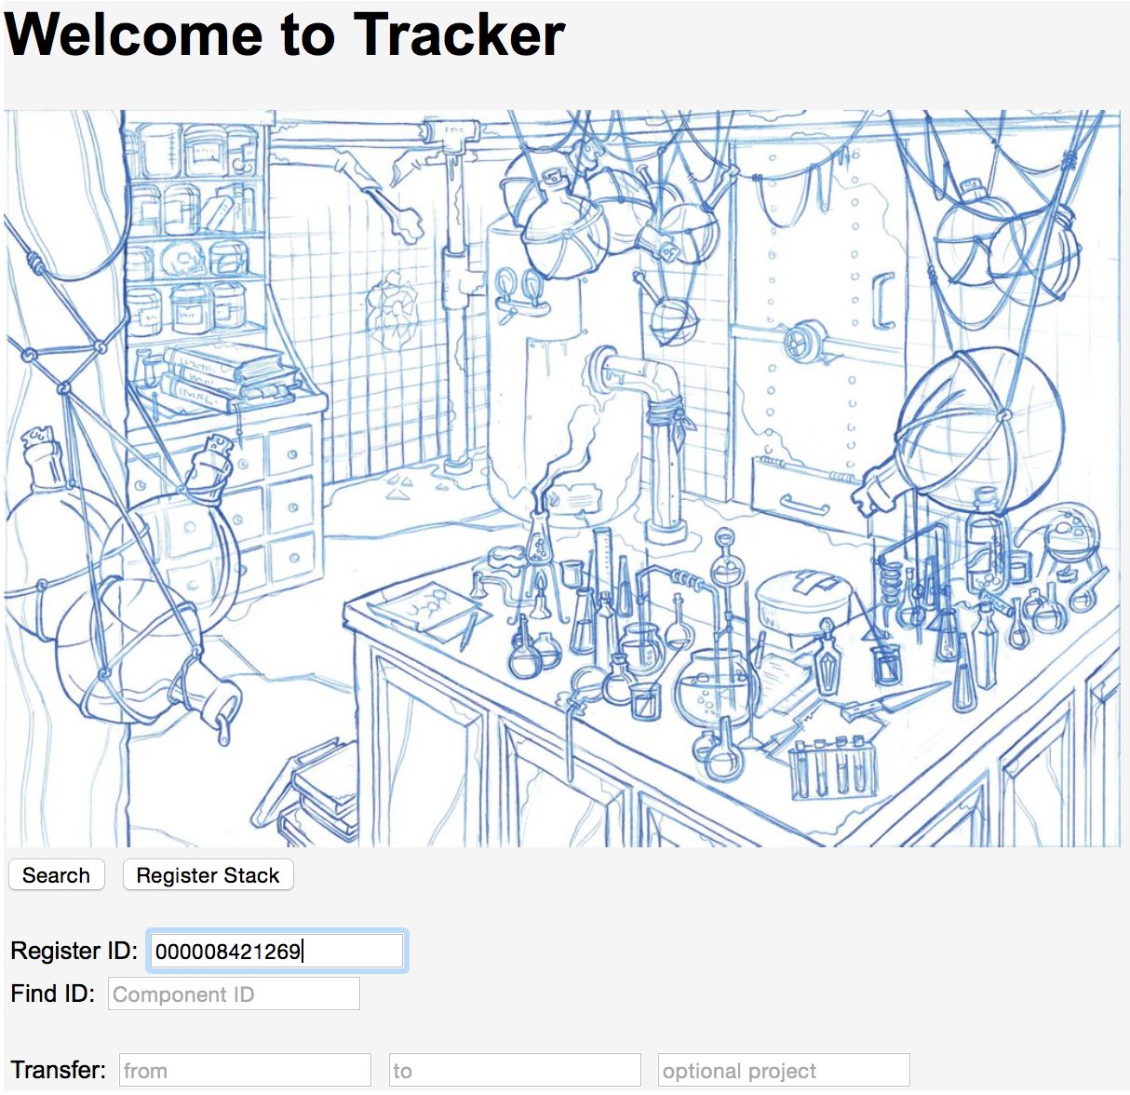

Initial registration of component from home page

After the barcode is entered the next page asks for the *Component Type*. Select *Rack* and then *Continue*.

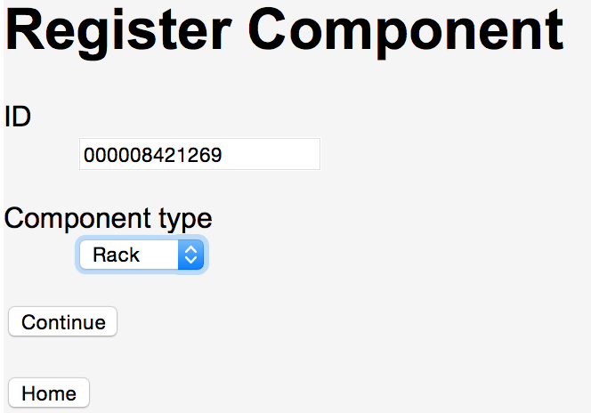

Selecting component type for registration

Next the page to enter additional information about the rack is displayed. *Initial Content* must be set to *BSP samples* and the *Project ID* should be set to the Jira ticket number associated with this rack. Optionally a description or tags can be entered to further identify the rack.

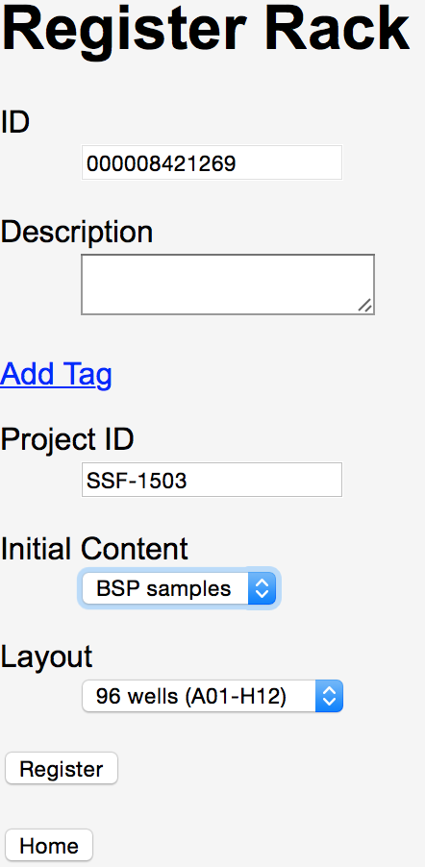

Completing rack registration

After *Register* is selected the registration is done and you are returned to Tracker’s home page, where a status message is displayed at the top.



## Scan of Rack Contents

Next the rack’s contents are input. A scan is done of the tubes 2D barcodes and the results are entered into Tracker as a *Scan File*. Select the *Choose File* button below *Scan File* and select the “csv” file created by the rack scan in the browser’s file selection dialog box. Once the file is selected the update page will show the name of the file. Select the *Update* button to associate the rack with the chosen file.

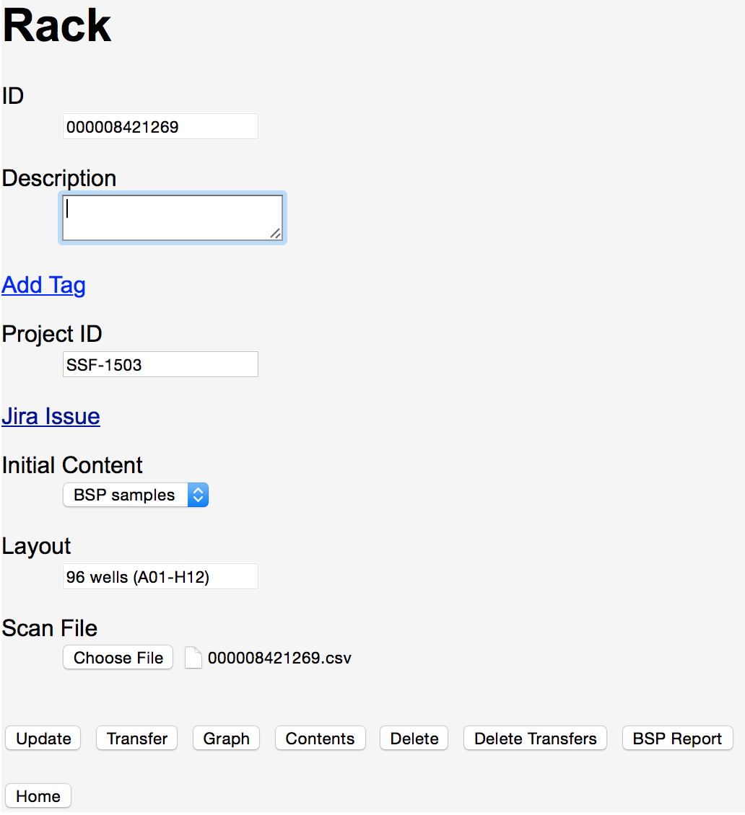

Selecting scan file for rack update

Upon completion of the update you return to the home page where the status report is displayed.



## Confirmation of Rack Contents

To verify that the tubes haven’t changed since arriving from BSP return to the rack’s display page by scanning the rack’s barcode into the Find ID field on the home page.

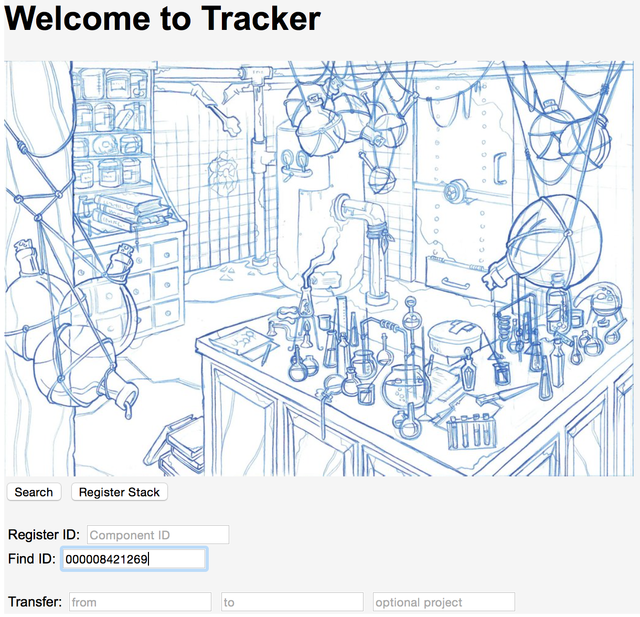

Finding a component to display

Selecting the *BSP Report* button on the rack’s display page presents a color-coded report flagging any possible problems with the rack’s tubes. At each rack location where a tube is found the sample ID for the tube is displayed.

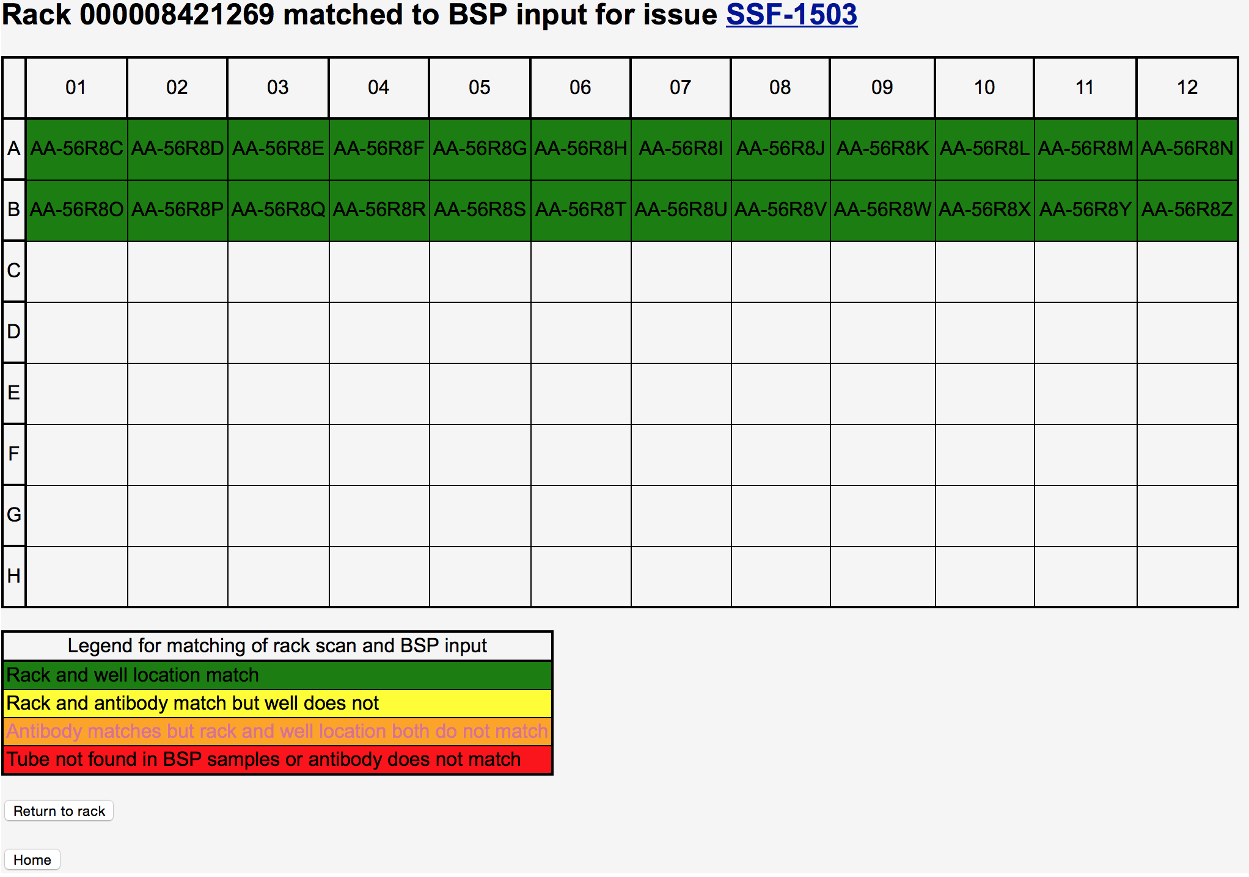

BSP report for ChIP-Seq samples

## Creation of Manufacturer Antibody Tubes

As a part of ChIP-Seq projects antibodies are used. The needed antibodies are ordered from outside vendors, arriving in barcoded tubes. These are the “mother” tubes, kept in the lab, from which needed aliquots are taken. Each of these tubes is registered in Tracker, with *Initial Content* set to the antibody contents of the tube. To register a tube: 1. Enter the tube’s barcode in the *Register ID* of Tracker’s home page. 2. Select *Tube* as the *Component Type* in the Register Component page. 3. Enter the wanted antibody as the Tube’s *Initial Content* in the Register Tube page before doing a *Register* of the tube.

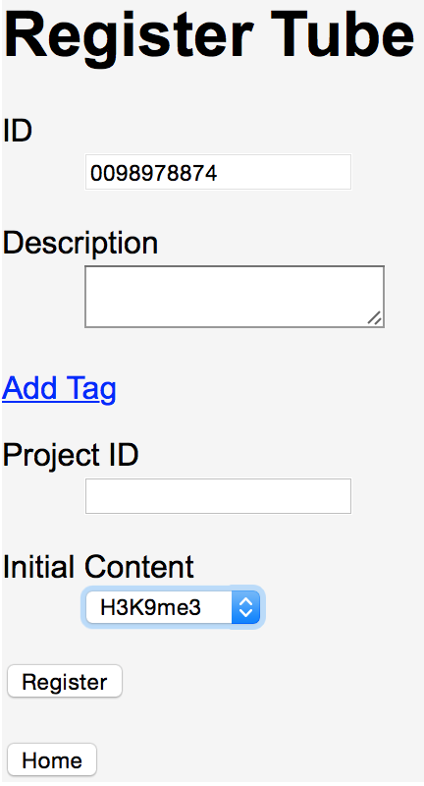

Registering an antibody tube

## Creation of Antibody Rack

Collaborators, when returning samples to BSP, specify the sample/antibody associations wanted for their experiments. The first step to making a plate with antibodies is to create tubes that have aliquots from the source antibody tubes. It is easiest to do this transfer by setting up two racks: One with the mother tubes to be transferred from, and one with the initially empty “daughter” tubes, the destinations for the transfers.

For the “mother” rack the necessary manufacturer tubes are placed in a rack in any locations. The manufacturer tubes must have been previously registered. Then the rack must be registered (*Initial Content* set as *Antibodies*) and a scan of the rack is entered as a rack update. Following the entry of the rack scan, selecting *Content* from the rack’s display page presents a page similar to the following:

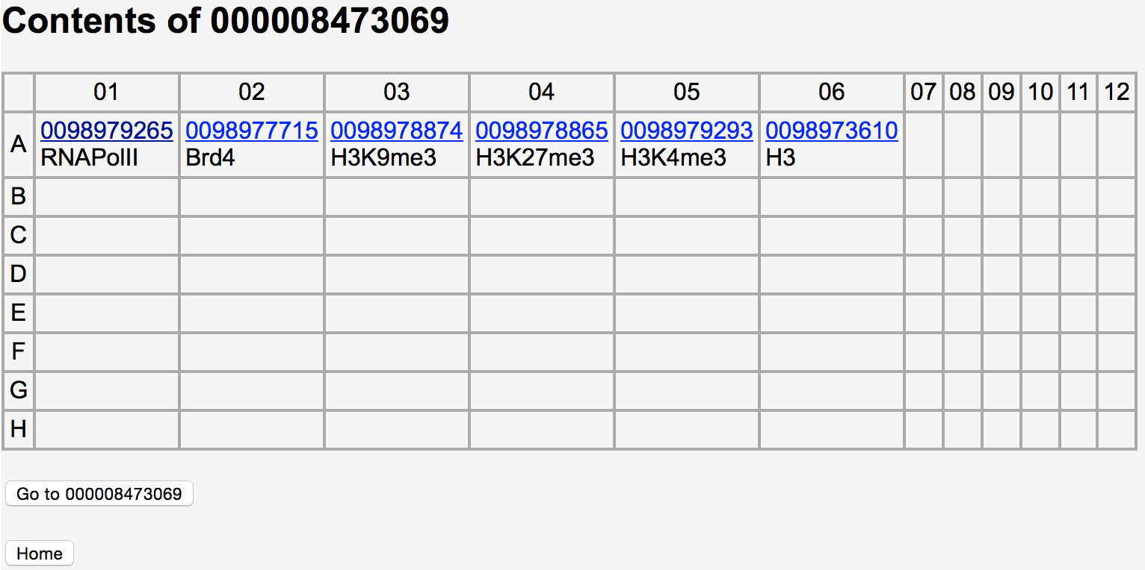

Displaying the contents of a rack of antibody tubes

Display pages for the individual tubes can be navigated to by selecting a tube barcode on the contents page.

To make the daughter tubes a new rack must be registered to hold the aliquot tubes. The daughter tubes do not have to be registered, but they do have to occupy the same positions as the source antibody tubes in the mother rack. As with the parent rack, the daughter rack is registered (*Initial Content* set as *Antibodies*) and a scan of the rack is entered as a rack update. When a scan of the rack is done, any tubes not already registered will be automatically registered in Tracker, so there is no need to manually register the individual tubes in the daughter rack.

To set the contents of the daughter tubes, a transfer is done from the mother to the daughter rack. On Tracker’s home page enter the source rack’s barcode in the *Transfer* from field and the destination rack’s barcode in the to field.

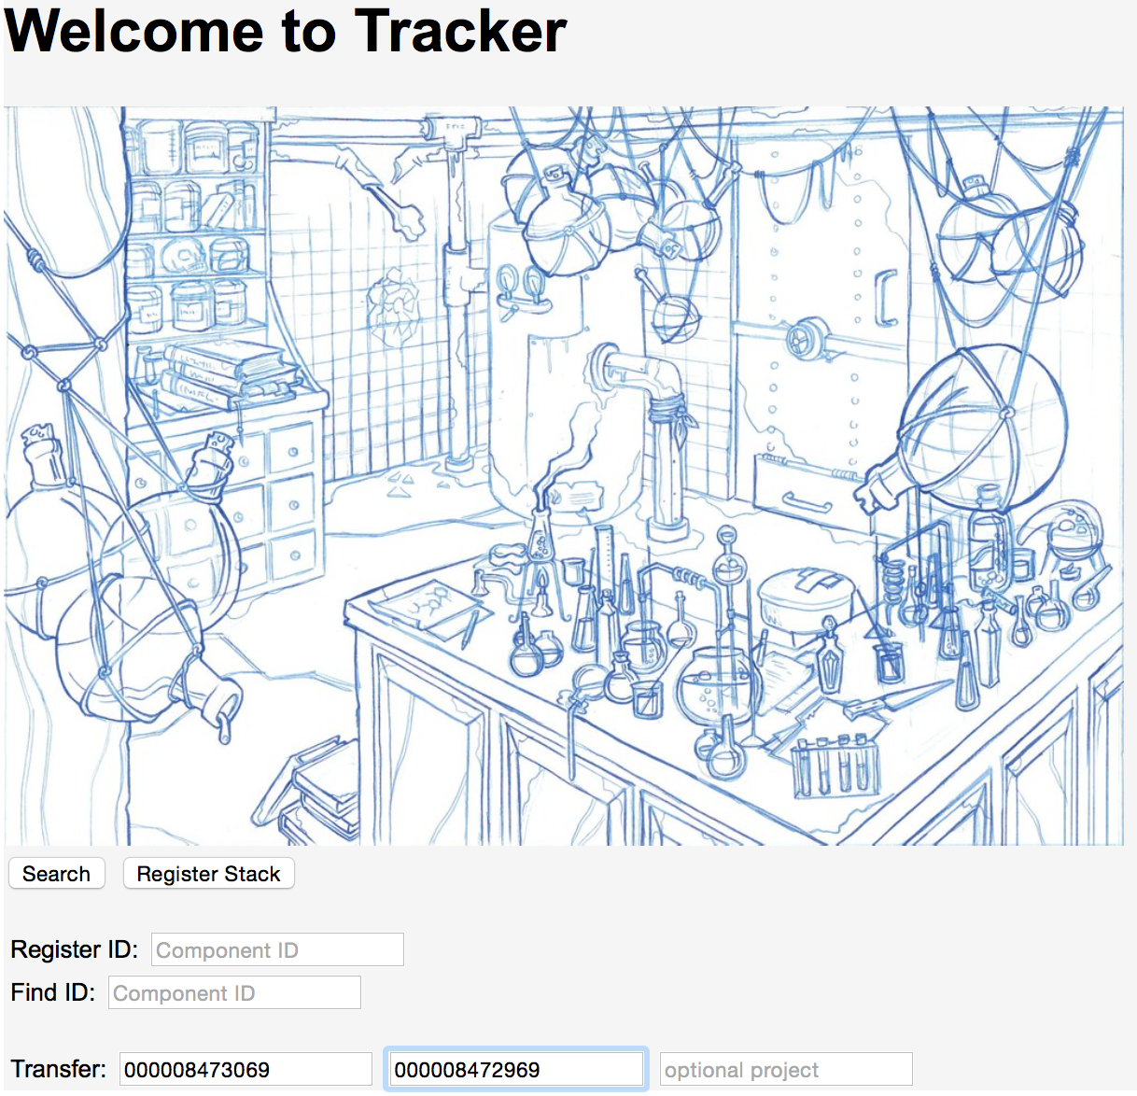

Initiating a transfer from the home page

Alternatively a transfer can be initiated by finding the source rack via a *Find ID* of the source rack, selecting *Transfer* from the rack’s display page and then setting the *To ID* in the Transfer Component page.

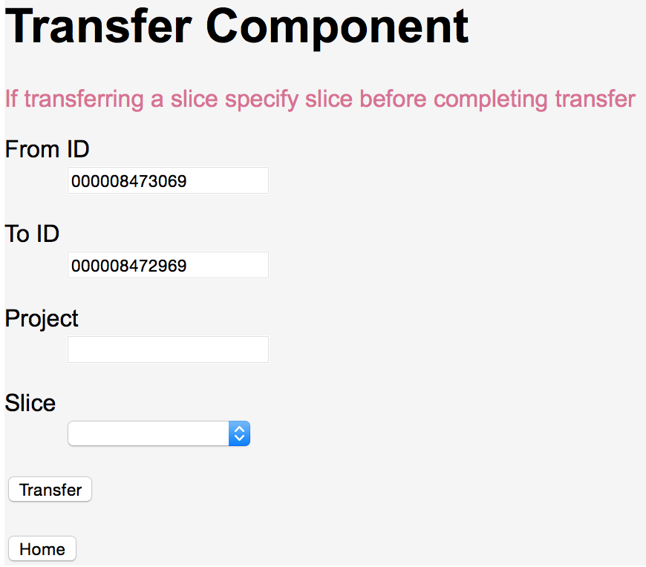

Completing transfer

Click on the *Transfer* button in the Transfer Component page to complete the transfer. You are returned to the home page where this message appears.



A transfer has been recorded, mother to daughter tube, for each set of tubes in the same position in both racks. These transfers assume that the actual transfer of aliquots between tubes is done in the lab in a parallel manner. In particular, transfers must only be done between tubes in the same positions. For example, an aliquot from the tube in position A01 from the source rack must go to the tube in position A01 in the destination rack.

## Creation of Antibody Plate

The next step is creation of the plate of antibodies to be attached to the samples. The plate is created on a Hamilton robot. Tracker is able to generate the directions for the robot as well as record the transfers that will take place when the robot follows the generated instructions. To generate Hamilton instructions select *Create Antibody Plate* from the daughter rack’s display page.

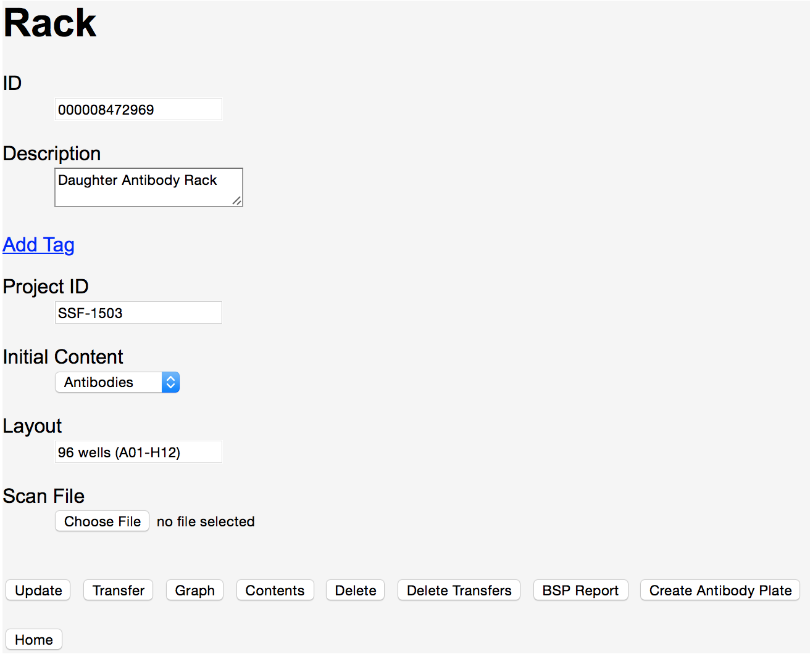

Daughter antibody rack display page used to initiate antibody creation

After *Create Antibody Plate* is selected the Create Robot Instructions page is displayed with *Antibody source rack ID* filled in. *Sample container ID* must be filled with the BSP rack barcode. The barcode on the destination plate is set in *Antibody destination plate ID*.

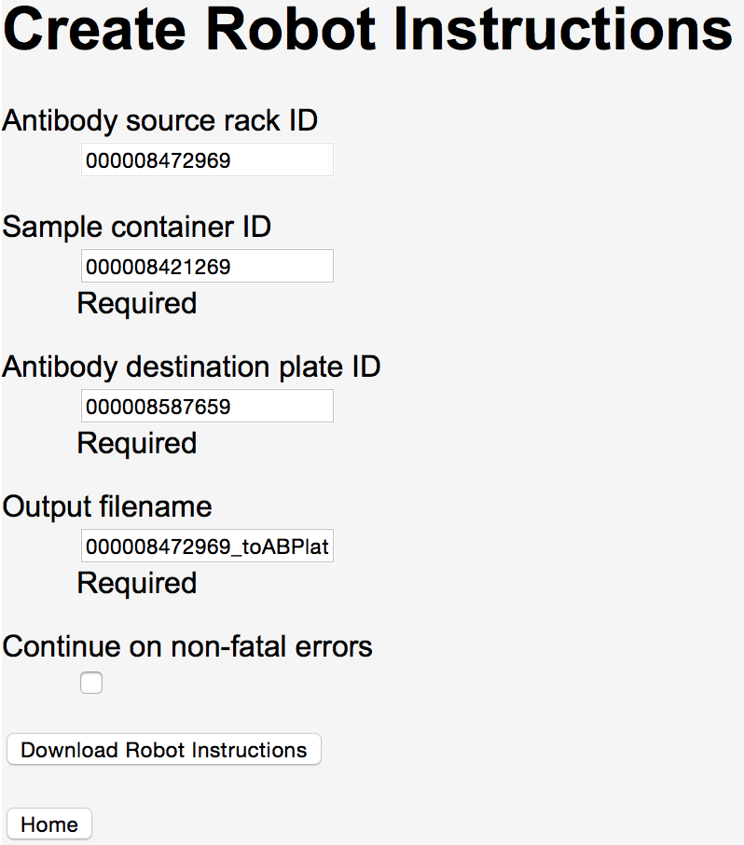

Filled in page to create robot instructions for an antibody plate

The destination plate need not be registered before the robot instructions are generated. Selecting the *Download Robot Instructions* button completes the following:

* Registration of the antibody destination plate.
* Generation of transfers from the antibody source rack tubes to the destination plate.
* Creating of a file in your download folder, with the *Output filename* and extension “csv”, containing the robot instructions.

An example of generated robot instructions is:

AB Name,Volume,Source AB Well Location,Destination Working Plate Well Location

H3K9me3,1,A3,A11

H3K9me3,1,A3,A10

H3K27me3,1,A4,B1

RNAPolII,1,A1,A4

H3,1,A6,B12

H3K4me3,1,A5,B5

Brd4,5,A2,A5

H3,1,A6,B9

H3K9me3,1,A3,A12

H3K27me3,1,A4,B2

H3K4me3,1,A5,B6

RNAPolII,1,A1,A1

Brd4,5,A2,A8

Brd4,5,A2,A6

RNAPolII,1,A1,A2

H3K27me3,1,A4,B3

H3,1,A6,B10

H3K4me3,1,A5,B8

H3K27me3,1,A4,B4

Brd4,5,A2,A7

H3K4me3,1,A5,B7

H3K9me3,1,A3,A9

RNAPolII,1,A1,A3

H3,1,A6,B11

At this point it is probably worth looking at what the contents of the destination plate are, to see where the antibodies have been placed in the plate. Back on the home page enter the plate’s barcode into the *Find ID* field, hit return to go to the plate’s display page and select *Contents* to show the antibody placement in the plate.

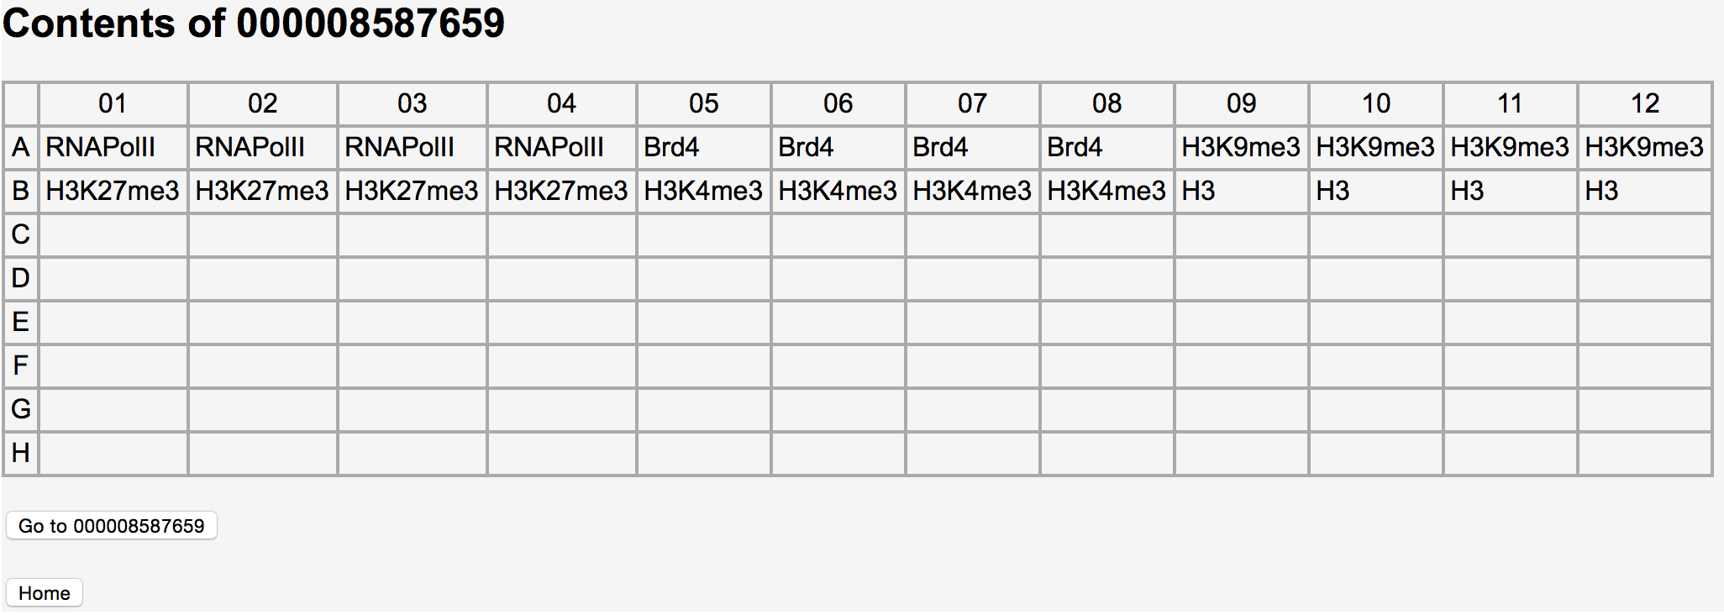

Contents for antibody plate created from robot instructions

Antibodies are set in wells corresponding to the locations of the samples, initially set in the BSP rack, destined to be connected with the antibodies.

## Creation of Molecular Barcode Plate

Besides antibodies, molecular barcodes (MIDs) are combined with samples. MIDs are a type of initial content for plates. MIDs come in sets. When the source plate containing the MIDs is registered choose the wanted MID set as the plate’s *Initial Content*.

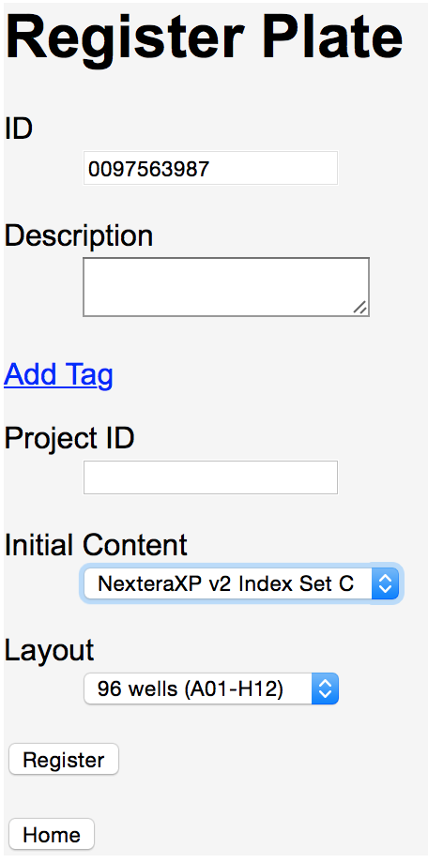

Registration of MID plate

## Combining all the pieces

Now that the sample rack, antibody plate and MID plate are in place you can start combining the components as necessary to complete the lab protocol. The actual protocol requires transfers into intermediate plates, before the MID, antibody and sample plates are combined into a single plate, but for our example we will simply make a sample plate from the BSP rack and then combine the MID, antibody and sample plate into a single plate before creating the sequencing tube.

First we register the sample plate via *Register ID* on Tracker’s home page. In the Register Component page set *Component type* as Plate and complete the registration on the Register Plate page.

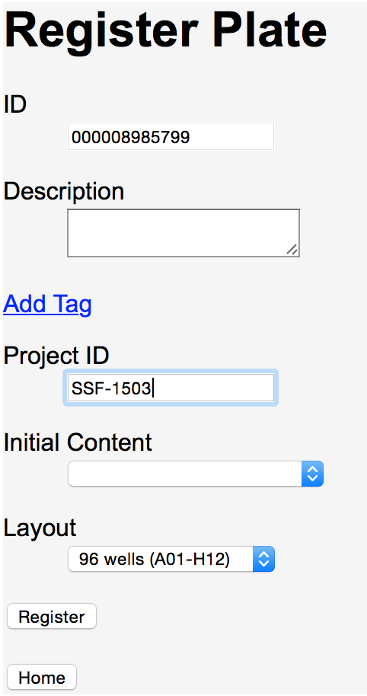

Registration of sample plate

To set the contents of the sample plate do a transfer from the BSP rack to the newly registered sample plate. On Tracker’s home page enter the BSP rack’s barcode in the *Transfer* from field and the destination rack’s barcode in the to field. Complete the transfer selecting the *Transfer* button in the Transfer Component page. To verify that the transfer has taken place go to the sample plate’s display plate and select *Graph* to see the following display.

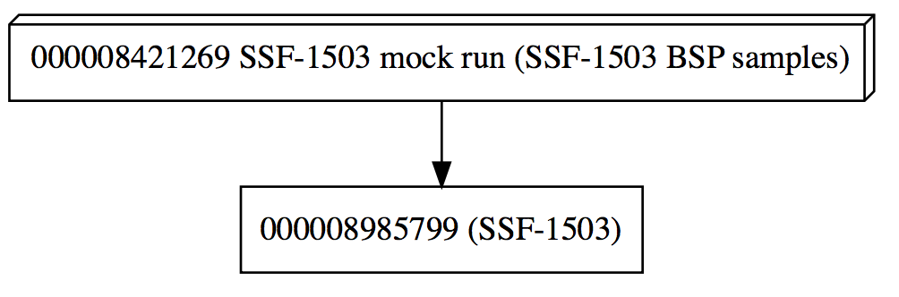

Graph of sample plate created from BSP rack

Next we register a new plate into which the samples, MIDs and antibodies are combined. After completing that registration the following transfers need to take place:

* Sample plate into newly registered combination plate.
* Antibody plate into combination plate.
* MID plate into combination plate.

All the transfers are of the complete plate (no *Slice* specified) except the MID plate. In the example, samples are only set in the 24 wells A01-A12 and B01-B12 so you should only transfer MIDs in those wells into the combination plate. This is done by specifying *Cherry Pick Wells* as a *Slice* on the Transfer Component page.

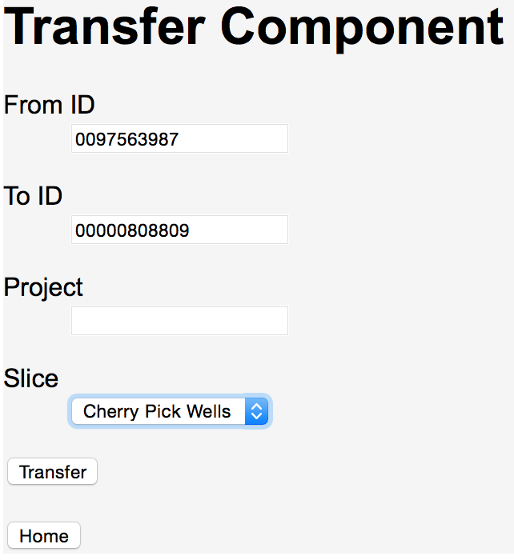

Transfer of MIDs using cherry picking

Specific wells to transfer are selected in the following page displayed after selecting *Transfer* on the Transfer Component page.

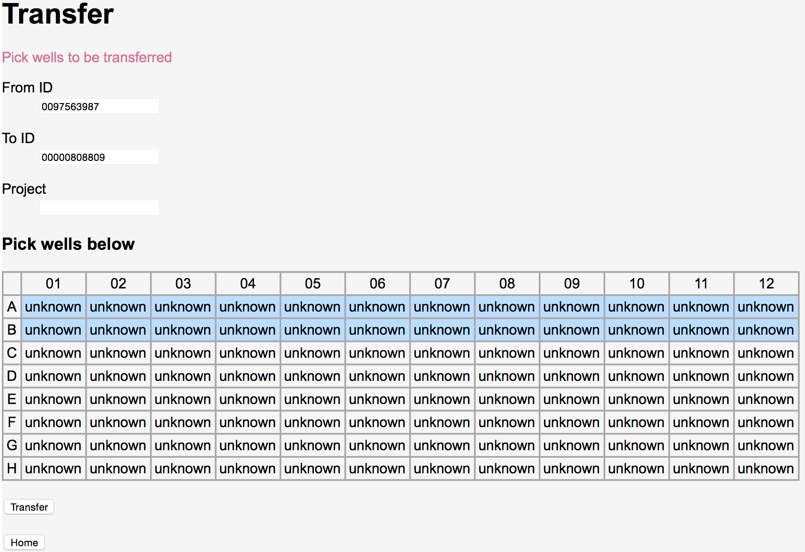

Select MID wells to be transferred

“unknown” is the wells’ contents because the source plate does not contain samples.

To see a graph of all the components now in use go to the display page for the final plate and select *Graph*.

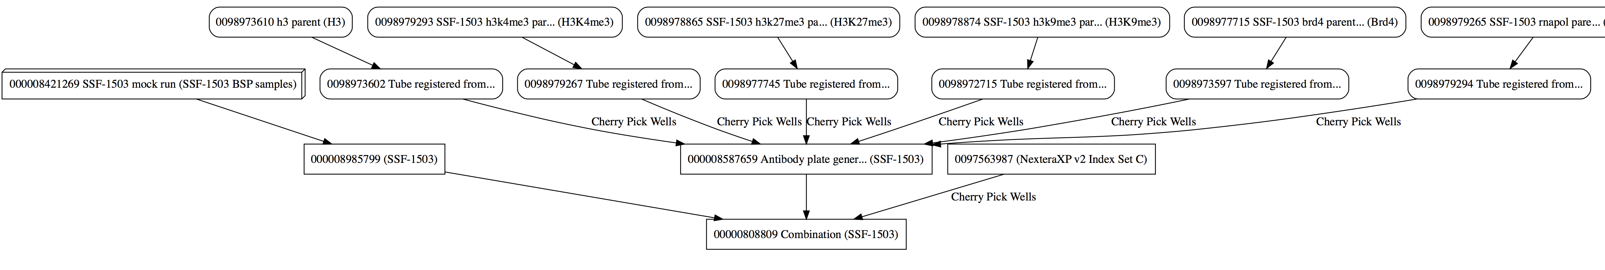

Graph of transfers into final plate

Selecting *Contents* on the display page shows the following:

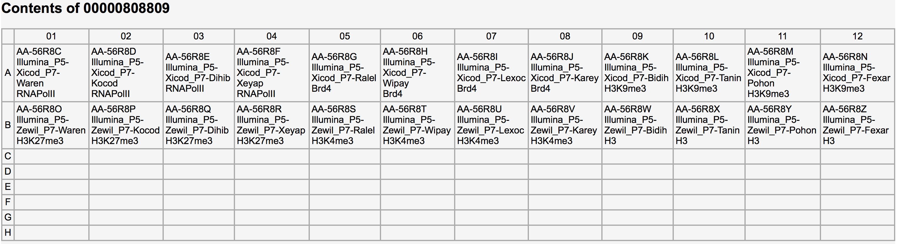

Contents of final plate

## Creating sequencing tube and walkup sequencing form

The final step is to create the sequencing tube and generate a walkup sequencing form. Register the sequencing tube and do a transfer from the final “combination” plate to the tube. To generate a walkup sequencing form, go to the sequencing tube’s display page and select *Create Walk Up File*. The file is downloaded with a name of the project ID (if specified) followed by a “_” and the tube’s barcode.

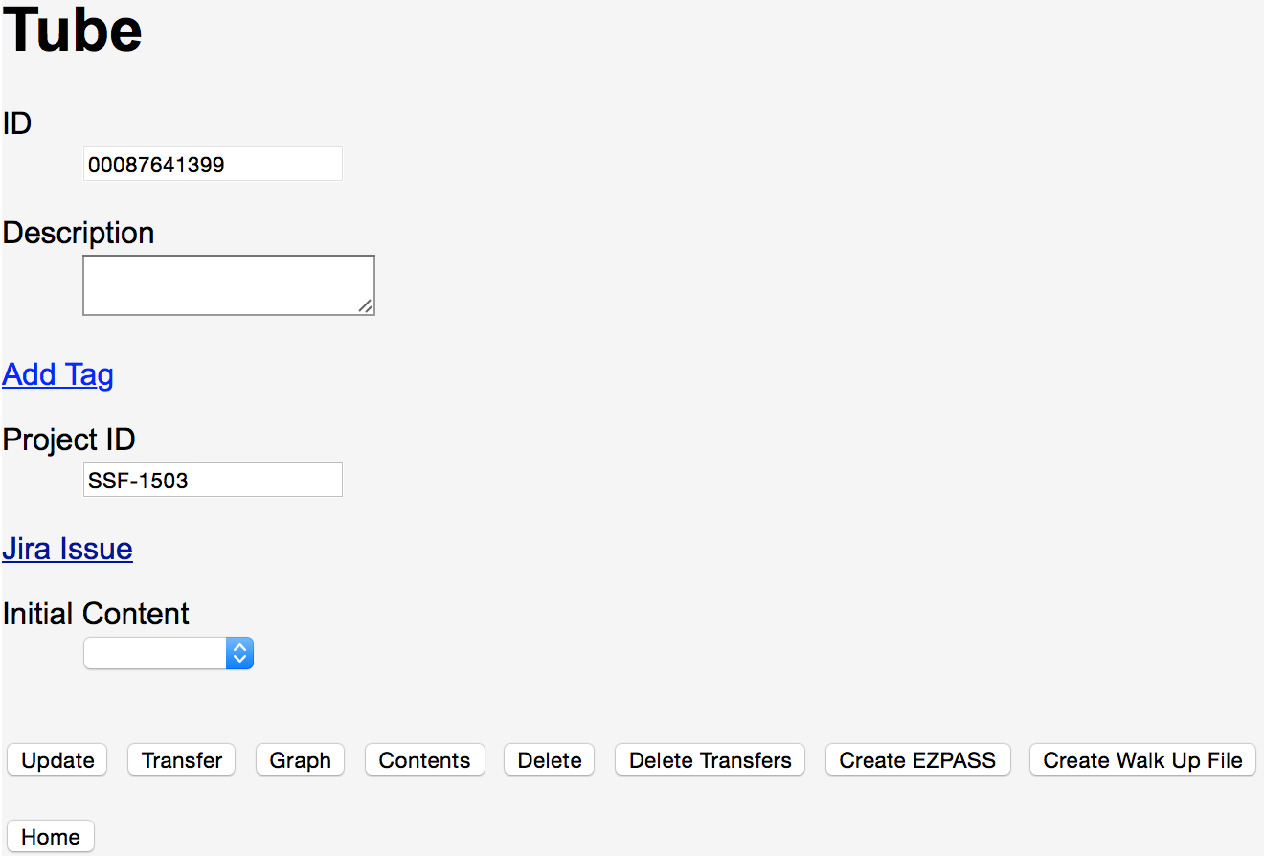

Creating walkup sequencing file

Following is an example walkup sequencing file:

SampleName,IndexBarcode1,IndexBarcode2

D458_sensitive_DMSO_RNAPolII_A01,TCGACTAG,TAAGGCGA

D458_sensitive_JQ1_H3_B10,TTCTAGCT,GTAGAGGA

D425_sensitive_JQ1_RNAPolII_A04,TCGACTAG,TCCTGAGC

D425_sensitive_JQ1_Brd4_A08,TCGACTAG,CGAGGCTG

D425_sensitive_DMSO_H3K9me3_A11,TCGACTAG,GCTCATGA

D425_sensitive_DMSO_H3K4me3_B07,TTCTAGCT,CTCTCTAC

D458_sensitive_DMSO_H3_B09,TTCTAGCT,AAGAGGCA

D425_sensitive_JQ1_H3K9me3_A12,TCGACTAG,ATCTCAGG

D458_sensitive_JQ1_H3K9me3_A10,TCGACTAG,GTAGAGGA

D425_sensitive_DMSO_H3K27me3_B03,TTCTAGCT,AGGCAGAA

D458_sensitive_DMSO_H3K4me3_B05,TTCTAGCT,GGACTCCT

D425_sensitive_DMSO_H3_B11,TTCTAGCT,GCTCATGA

D458_sensitive_DMSO_H3K9me3_A09,TCGACTAG,AAGAGGCA

D458_sensitive_JQ1_H3K4me3_B06,TTCTAGCT,TAGGCATG

D458_sensitive_JQ1_RNAPolII_A02,TCGACTAG,CGTACTAG

D425_sensitive_JQ1_H3K27me3_B04,TTCTAGCT,TCCTGAGC

D458_sensitive_JQ1_Brd4_A06,TCGACTAG,TAGGCATG

D425_sensitive_JQ1_H3_B12,TTCTAGCT,ATCTCAGG

D458_sensitive_JQ1_H3K27me3_B02,TTCTAGCT,CGTACTAG

D425_sensitive_DMSO_Brd4_A07,TCGACTAG,CTCTCTAC

D425_sensitive_JQ1_H3K4me3_B08,TTCTAGCT,CGAGGCTG

D458_sensitive_DMSO_H3K27me3_B01,TTCTAGCT,TAAGGCGA

D458_sensitive_DMSO_Brd4_A05,TCGACTAG,GGACTCCT

D425_sensitive_DMSO_RNAPolII_A03,TCGACTAG,AGGCAGAA